Performance of the demonstration under CFLD on Oilseed Crops during Kharif 2024 :

- Technical Parameters:
Sl.  No. | Crop demonstrated | Existing (Farmer's) variety name | Existing yield  (q/ha) | Yield gap (Kg/ha)  w.r.to |  |  | Name of Variety + Technology  demonstrated | Number of farmers | Area in ha | Yield obtained (q/ha) |  |  | Yield gap minimized  (%)
 |  |  |  | District  yield (D) | State  yield (S) | Potential  yield (P)
 |  |  |  |  |  |  |  |  |  | Max. | Min. | Av. | D | S | P
1. | Sesame | Local | 5.5 | 4.12 | 3.98 | 9.0 | Providing new high yielding verity of Sesame (Var. Suprava) along with package of practice.  Proper weed management practices with post emergence herbicide like Quizal fop ethayl 10SL @ 800 ml/ha.  Proper seed treatment was followed by use of PSB (20g/kg of seed) during sowing.  Application of plant protection chemical like Chloropyriphos (20EC)@ 1L/ha at 25 DAS to manage lepidopteran pests.  Application of Sulphur @ 5gm/lit at 21 DAS.  Application of Water soluble fertilizer, like N,P, K and boron at pre flowering stage and flowering stage.  Application of Flubendiamide and Thiacloprid@ 0.3 ml/ lit followed by neem based pesticide @ 5 ml/ lit to control pod borer and Cercospora leaf spot.  Inundative releases of Trichogramma chilonis @ 20DAS,30DAS,& 45 DAS to manage pod borer, leaf webber. | 100 | 60 | 9.0 | 2.0 | 5.5 | 30.47 | 17.8 | 6  3.6
1. | Sesame | Local | 5.2 | 4.0 | 3.98 | 8.0 | Providing new high yielding verity of Sesame (Var. Smarak) along with package of practice.Same technology | 50 | 20 | 8.0 | 2.4 | 5.2 | 28.47 | 158 | 53.84

Sl.  No. | Variety demonstrated & Technology demonstrated | Farmer’s Existing plot |  |  |  | Demonstration plot
Sl.  No. | Variety demonstrated & Technology demonstrated | Gross Cost  (Rs/ha) | Gross return  (Rs/ha) | Net Return  (Rs/ha) | B:C  ratio | Gross Cost  (Rs/ha) | Gross return  (Rs/ha) | Net Return  (Rs/ha) | B:C  ratio
1. | Sesame  Var.  Suprava  Technology Proper weed management practices with post emergence herbicide like Quizal fop ethayl 10SL @ 800 ml/ha.  Proper seed treatment was followed by use of PSB (20g/kg of seed) during sowing.  Application of plant protection chemical like Chloropyriphos (20EC)@ 1L/ha at 25 DAS to manage lepidopteran pests.  Application of Sulphur @ 5gm/lit at 21 DAS.  Application of Water soluble fertilizer, like N,P, K and boron at pre flowering stage and flowering stage.  Application of Flubendiamide and Thiacloprid@ 0.3 ml/ lit followed by neem based pesticide @ 5 ml/ lit to control pod borer and Cercospora leaf spot.  Inundative releases of Trichogramma chilonis @ 20DAS,30DAS,& 45 DAS to manage pod borer, leaf webber. | Rs. 21,800/- | Rs. 36,141 /- | Rs.  14, 341 /- | 1.66 | Rs.  24,900 /- | Rs. 50,968 /- | Rs. 26,068/- | 2.05
- Economic parameters

Sl.  No. | Crop and variety  Demonstrated | Total Produce  Obtained (kg) | Produce sold  (Kg/household) | Selling  Rate  (Rs/Kg) | Produce used for own sowing (Kg) | Produce distributed to other farmers (Kg) | Purpose for which income gained was utilized | Employment Generated (Mandays/house hold)
1. | Sesame  (Suprava) | 550 | 420  kg/Household | Rs.93 | 100 | 30 | Agriculture and  household needs. | 35 MD
- Socio-economic impact parameters

- Oilseed Farmers’ perception of the intervention demonstrated
Sl.  No. | Technologies demonstrated  (with name) | Farmers' Perception parameters
Sl.  No. | Technologies demonstrated  (with name) | Suitability to their farming system | Likings  (Preference) | Affordability | Any negative effect | Is Technology acceptable to all in the group/village | Suggestions, for change/improvement, if any
1. | High yielding variety, seed treatment, Integrated Nutrient Management and Integrated Pest Management. | Suitable | Suprava variety obtaining good yield in Boudh district climate | Yes | No | Yes | This new high yielding variety Suprava of Sesame should be available consistently to the farmers for improvement.
2. | High yielding variety, seed treatment, Integrated Nutrient Management and Integrated Pest Management. | Suitable | Smarak  variety obtaining good yield in Boudh district climate | Yes | No | Yes | This new high yielding variety Smarak of Sesame should be available consistently to the farmers for improvement.

- Specific Characteristics of Technology and Performance
Specific Characteristic | Performance | Performance of Technology vis-a vis Local Check | Farmers Feedback
Good seed yield and is known for its high oil content(44-63%) It also exhibits moderate resistance to some diseases like powdery mildew and Alternaria, also excellent qualities of the seed oil like protein (18%–25%), and carbohydrates (13.5%).Non-shattering capsules reduce post-maturity seed loss. Suitable for intercropping systems and upland rainfed areas. Performs well even under moisture stress conditions. | Suprava exhibited 25% seed yield superiority over the best national check TKG 22. It is identified for summer in the states of Odisha, | Suprava' significantly outperforms local varieties in terms of yield, oil content, and economic returns. Early maturity and disease tolerance give it an advantage in rainfed and uncertain rainfall zones.Non-shattering capsules help in reducing seed loss and are suitable for semi-mechanized harvesting. A suitable variety for doubling farmers' income in sesame-growing regions. | Farmer observed and assessed specific characteristics of the demonstrated technologies and will adopt the technologies in subsequent years for crop production as the inputs available in their local markets.
Golden yellow bold seed, delayed shattering, Synchronous maturity, tolerant to macrophomina and alternaria leaf spot with seed yield 800-900 kg/ha,Oil content % -48-52 %, with maturity days 80-85. | 70–80% higher yield than traditional varieties. Higher oil content, fetching better market price.Non-shattering capsule reduces harvest and post-harvest losses. Early maturity suits rainfed and multiple cropping systems. | Smarak performed significantly better than local varieties in terms of yield, oil content, and economic returns.The variety is early maturing, allowing scope for multiple cropping or timely harvest in rainfed conditions.Its non-shattering capsule nature minimizes post-maturity losses, which is a key advantage over local types.With better disease resistance, especially against phyllody and stem rot, it ensures stable yield under stress. | Farmers appreciated the non-shattering capsule, uniform seed color, and disease tolerance.Many expressed interest in saving their own seeds for next season.The variety was widely adopted in cluster frontline demonstrations (CFLDs) with positive economic results.Farmers reported increased income and seed-saving practices.

- Extension activities under FLD conducted:
Sl. No. | Extension Activities organized | Date and place of activity | Number of farmer attended
 | Farmers training | 10.09.2024 at Tavapadar village | 100 nos.
 | Field Day | 06.12.2024 at Brahmanipalli village | 50 nos.

- Sequential good quality photographs (as per crop stages i.e. growth & development)
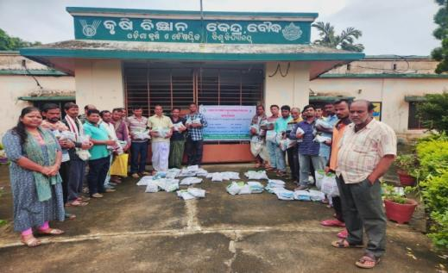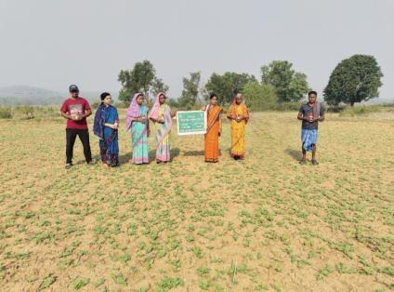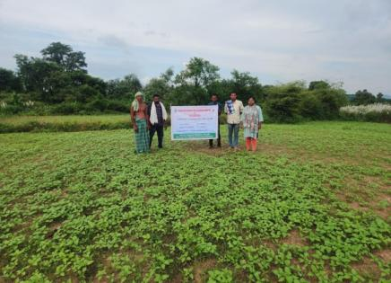
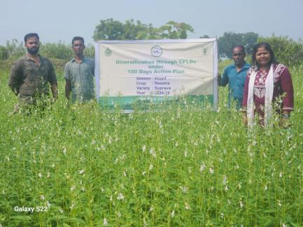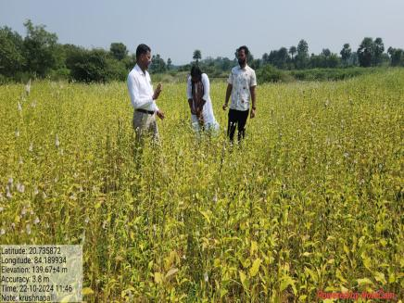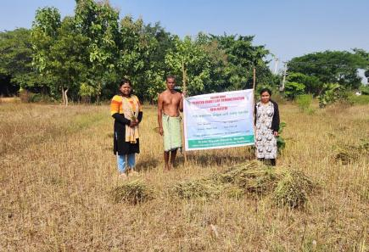

- Farmers' training photographs
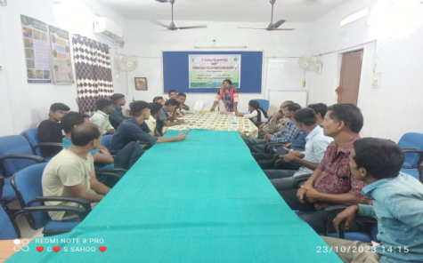
- Quality Action Photographs of field visits/field days and technology demonstrated.

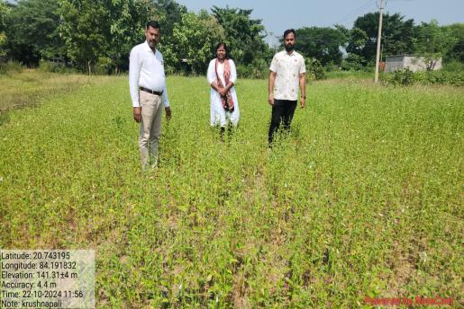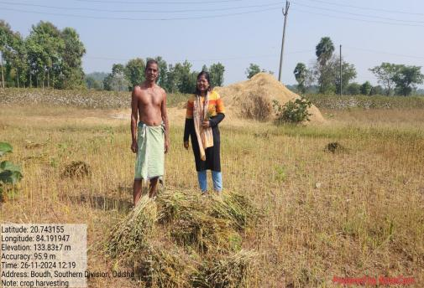

J. Details of budget utilization (Summer+ Kharif)

Crop  (provide crop wise information ) | Items | Budget  Received  (Rs.) | Budget  Utilization  (Rs.) | Balance  (Rs.)
Sesame | i) Critical input | Rs.5,88,647 | Rs .541473 | Nil
Sesame | ii) TA/DA/POL etc. for monitoring | Rs.5,88,647 | - | -
Sesame | iii) Extension Activities (Field day) | Rs.5,88,647 | Rs .11250 | Nil
Sesame | iv)Publication of literature | Rs.5,88,647 | Rs .9879 | Nil
Sesame | Miscelleneous | Rs.5,88,647 | Rs .6711 | Nil
Sesame | Technology Agent | Rs.5,88,647 | Rs .19334 | Nil
Sesame | Total | Rs. 4,88,647 | Rs. 4,88,647 | Nil

