Success Story 2021-22
Season (Kharif) : Groundnut
Name of KVK | Krishi Vigyan Kendra,Boudh
Crop and variety | Groundnut  Variety: Devi-ICGV-91114
Name of farmer & address | Shri. Biswamitra Mahakud  Khuntiapada,Boudh  Contact No.9178389913
Details of technology demonstrated | HYV seed- Devi, Seed tratment with Vitavax-2gm/kg seed,Application of Herbicide: Imazathypr,Application of Indoxcarb and Neemoil as Plant Protection Measure
Success point | Less Number of Weeds , crop less affected by wilt, leaf spot and from major pests ,early maturing and high yield.
Farmer feedback | satisfied with Variety & technology
Yield (q/ha)  - Potential yield of variety  - District average (Previous year)  - State average (Previous year) | 20 qt/ha  15.5 qt/ha  17.2 qt/ha

Performance of technology vis-à-vis Local check (Increase in productivity and returns)

Used Practice | Yield (q/ha) | Gross cost (Rs/ha) | Gross income (Rs/ha) | Net income  (Rs/ha) | B:C ratio
Farmer practices | 14.5 | 23000 | 96795 | 73795 | 3.62
Demonstration | 18.5 | 22500 | 113225 | 89725 | 4.78
% Increase in yield | 21.60

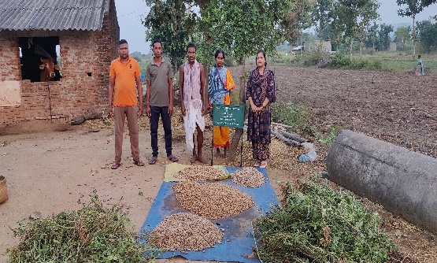
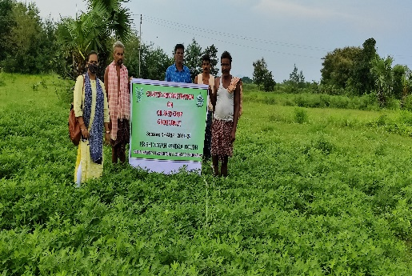
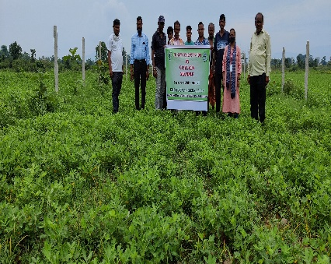
Quality Photographs: in .jpeg format

