Success Story Format for CFLD Oilseeds under SAP
Specific Technology:-Variety Uttara with line Sowing, use of Herbicides and Plant protection measures.
Name of KVK | KrishiVigyanKendra,Boudh,Odisha
Crop and variety | Mustard, UTTARA
Name of farmer & address | Sushanta Kheti, Kulutakhali, Boudh
Details of technology demonstrated | Seed Variety ( Uttara)+seed treatment +soil test based fertiliser, Micronutrient and required pp chemicals
Success point | Less Number of Weeds , crop less affected by aphids, less infestation of disease and pest &more yield
Farmer feedback | satisfied with Variety& technology
Yield (q/ha)  - Potential yield of variety  - District average (Previous year)  - State average (Previous year) | 6.2  4.9  5.4

Performance of technology vis-à-vis Local check (Increase in productivity and returns)
Used  Practice | Yield (q/ha) | Gross cost (Rs/ha) | Gross income (Rs/ha) | Net income  (Rs/ha) | B:C ratio
Farmer practices | 5.2 | 12500 | 23050 | 10550 | 1.84
Demonstration | 6.4 | 13600 | 29450 | 13850 | 2.16
% Increase in yield | 23%

Quality Photographs: in .jpeg format
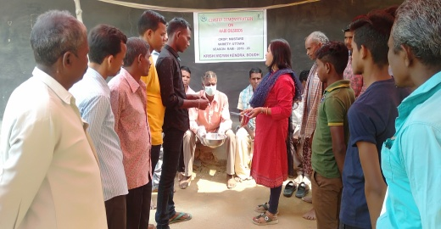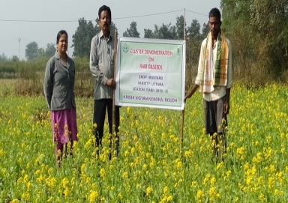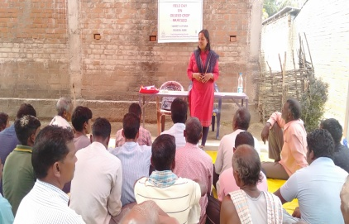
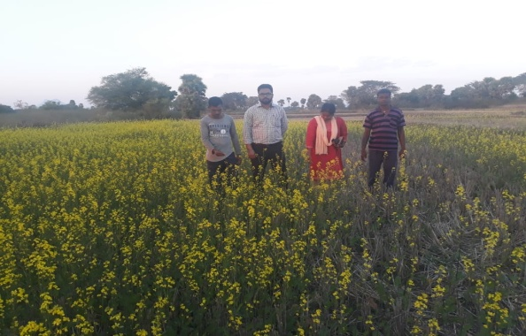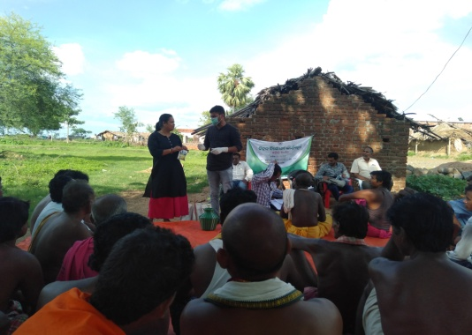
Seed treatment awareness programme organized by KVK,Boudh

