Physical Progress Report of CFLD Kharif Oilseed Programme-2024
Name of KVK | KVK, Boudh
Crop and Variety | Sesame var. Suprava (2018)
Nos. Of demonstration conducted | 100 nos.
Nos. Of farmers | 100 nos.
No. Of cluster | 3 nos. (Brahmanipali of Boudh block, Khwandahata, and Tavapadar villages of Harbhanga block).
Background information about farmer field | Previously the farmer mainly cultivating Rice in kharif season and after kharif land was fallow till next Kharif season.Soil testing has been done for better knowing of nutrient level in soil which help him for better crop growth.
Details of technology demonstrated | - Providing new high yielding verity of Sesame (Var. Suprava) along with package of practice.  - Proper weed management practices with post emergence herbicide like Quizal fop ethayl 10SL @ 800 ml/ha.  - Proper seed treatment was followed by use of PSB (20g/kg of seed) during sowing.  - Application of plant protection chemical like Chloropyriphos (20EC)@ 1L/ha at 25 DAS to manage lepidopteran pests.  - Application of Sulphur @ 5gm/lit at 21 DAS.  - Application of Water soluble fertilizer, like N,P, K and boron at pre flowering stage and flowering stage.  - Application of Flubendiamide and Thiacloprid@ 0.3 ml/ lit followed by neem based pesticide @ 5 ml/ lit to control pod borer and Cercospora leaf spot.  - Inundative releases of Trichogramma chilonis @ 20DAS,30DAS,& 45 DAS to manage pod borer, leaf webber.
Success Point | - Better weed management practices by applying suitable herbicide as post emergence.  - Application of macronutrient like Sulphur to enhance the oil content percentage.  - Application of Boron before flowering and flowering stage to increase  - the number of siliqua/plant.  - Pod borer incidence reduced by 83% by application of Flubendiamide and Thiacloprid@ 0.3 ml/ lit followed by neem based pesticide @ 5 ml/ lit during vegetative and flowering stage.
Farmer Feedback | Farmer are satisfied with the performance of the new verity and by adopting new technologies because profit was doubled.
Outcome Yield (q/ha)  Demonstration | 5.5q/ha
Potential yield of variety/technology | 9.0 q/ha
District average (Previous year) | 4.12 q/ha
- State average  (Previous year) | 3.98 q/ha
Performance of technology :
Specific Technology | Yield (q/ha) | Gross cost (Rs/ha) | Gross income (Rs/ha) | Net income  (Rs/ha | B:C ratio
Farmer practices | 3.9 | Rs. 21,800/- | Rs. 36,141 /- | Rs.14, 341 /- | 1.66
Demonstration | 5.5 | Rs. 24,900 /- | Rs. 50,968 /- | Rs. 26,068/- | 2.05
% Increase | 41 %
Yield gap with potential yield in % | 63.6%

Good Quality Photographs:
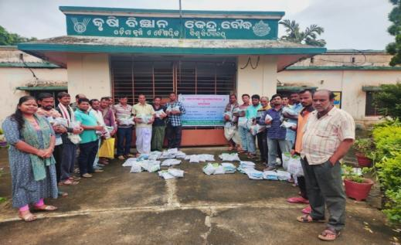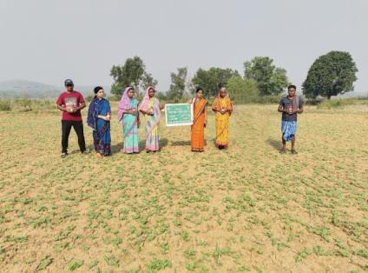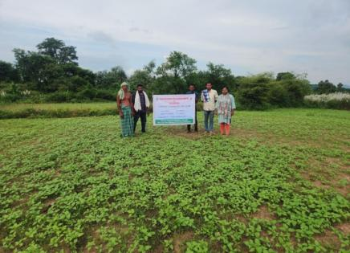
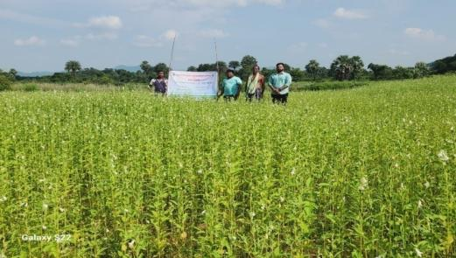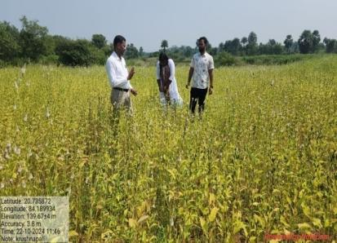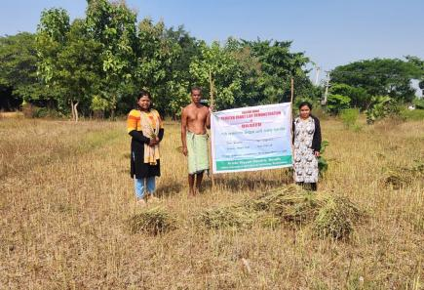

Sd/-
Sr. Scientist & Head
KVK, Boudh

