CLUSTER FRONTLINE DEMONSTRATION OF KHARIF PULSES (2019-20) PERFORMANCE DATA REPORTING
- Name of KVK: BOUDH 5. Year of establishment:2005
- Host Institution:-OUAT,Bhubaneswar 6. Address: At-Paljhar,P.O-Salunki, Dist-Boudh,751003
3. District:-Boudh 7. State: ODISHA
4. Performance of the demonstration: Good
- Technical Parameters:
Sl.  No. | Crop demonstrated | Existing (Farmer's) variety name | Existing yield  (q/ha) | Yield gap (Kg/ha)  w.r.to |  |  | Name of Variety + Technology  demonstrated | Number of farmers | Area in ha | Yield obtained (q/ha) |  |  | Yield gap minimized  (%)
 |  |  |  | District  yield (D) | State  yield (S) | Potential  yield (P)
 |  |  |  |  |  |  |  |  |  | Max. | Min. | Av. | D | S | P
1 | Pigeonpea | Kandula | 9.5 | 145 | 54 | -650 | Use of HYV PRG 176; Seed treatment with carboxin+ thiram; Application of herbicides(pendimethalin and imazethapyr) | 25 | 10 | 14.0 | 11.8 | 12.9 | 2.94q | 8.45q | -2.1q
2 | Greengram | Jhainmoog | 6.7 | 503 | 476 | 1204 | - Use of HYV(IPM-02-03)Seed treatment with carboxin+ thiram; Application of herbicides(pendimethalin 2.5 lit/ha  - Application of Imidacloprid @0.4 ml/litcontrol sucking pest attack | 25 | 10 | 7.5 | 5.7 | 6.7 | 1.63 | 1.90 | -5.7
3 | Blackgram | Local | 5.28 | 190 | 70 | -672 | Use of HYV (PU-31);  Seed treatment with carboxin+thiram; Application of herbicide(pendimethalin and imazethapyr); Plant protection measures (Application of prophenophos+ cypermethrin against Red Hairy caterpillar. | 25 | 10 | 8.64 | 6.18 | 7.45 | 54.6 | 38.5 | -61.1
- Economic parameters
Sl.  No. | Variety demonstrated & Technology demonstrated | Farmer’s Existing plot |  |  |  | Demonstration plot
Sl.  No. | Variety demonstrated & Technology demonstrated | Gross Cost  (Rs/ha) | Gross return  (Rs/ha) | Net Return  (Rs/ha) | B:C  ratio | Gross Cost  (Rs/ha) | Gross return  (Rs/ha) | Net Return  (Rs/ha) | B:C  ratio
1 | Use of HYV(PRG-176) Seed treatment with carboxin+ thiram; Application of herbicides(pendimethalin and imazethapyr) | 22650 | 43200 | 20550 | 1.9 | 24200 | 51600 | 27400 | 2.1
2 | - Use of HYV(IPM-02-03)Seed treatment with carboxin+ thiram; Application of herbicides(pendimethalin 2.5 lit/ha  - Application of Imidacloprid @0.4 ml/litcontrol sucking pest attack | 27650 | 37100 | 9450 | 1.34 | 20200 | 46900 | 17700 | 1.6
3 | Use of HYV (PU-31); Seed treatment with carboxin+thiram; Application of herbicide(pendimethalin and imazethapyr); Plant protection measures (Application of prophenophos+ cypermethrin against leaf eating caterpiller | 18600 | 26400 | 7800 | 1.42 | 22990 | 37250 | 14260 | 1.62

- Socio-economic impact parameters
Sl.  No. | Crop and variety  Demonstrated | Total Produce  Obtained (kg) | Produce sold  (Kg/household) | Selling  Rate  (Rs/Kg) | Produce used for own sowing (Kg) | Produce distributed to other farmers (Kg) | Purpose for which income gained was utilized | Employment Generated (Mandays/house hold)
1 | Pigeonpea  (PRG-176) | 12900 | 50 | 40 | 100 | 190 | For next season farming and house expenses | 90
2 | Greengram  (IPM-02-03) | 670 | 500 | 70 | 70 | 100 | Sold as seed | household expenditure
3 | Blackgram  (PU-31) | 14903 | 183 | 50.00 | 2833 | 4560 | Social function ,Education of children | 52

- Farmers’ perception of the intervention demonstrated
Sl.  No. | Technologies demonstrated  (with name) | Farmers' Perception parameters
Sl.  No. | Technologies demonstrated  (with name) | Suitability to their farming system | Likings  (Preference) | Affordability | Any negative effect | Is Technology acceptable to all in the group/village | Suggestions, for change/improvement, if any
1 | HYV of Pigeonpea (PRG-176); Seed treatment with carboxin+ thiram; Application of herbicides(pendimethalin and imazethapyr) | Suitable | Very good | 75% | No | Yes | No
2 | - Use of HYV(IPM-02-03)Seed treatment with carboxin+ thiram; Application of herbicides(pendimethalin 2.5 lit/ha  - Application of Imidacloprid @0.4 ml/litcontrol sucking pest attack | Suitability to their farming system | Preferred | 72% | nil | yes | No
3 | HYV of Blackgram (PU-31); Seed treatment with carboxin+thiram; Application of herbicide(pendimethalin and imazethapyr); Plant protection measures (Application of prophenophos+ cypermethrin against leaf eating caterpiller | Suitable | Very good | 70% | No | Yes | Timely availability of seed

- Specific Characteristics of Technology and Performance
Specific Characteristic | Performance | Performance of Technology vis-a vis Local Check | Farmers Feedback
HYV Pigeonpea variety (PRG-176) Medium duration: 150 days; Plant ht:140-227 cm; 50% flowering: 110-125 days; 75% flowering: 160-202 days; seeds brown, oval; 100 seed wt: 10.2-11.2 g; Potential yield:15-16q/ha; Resistant to fusarium wilt and sterility mosaic | Well in farmer’s field | Demonstrated technology of improved variety with seed treatment; weed management by herbicides and proper plant protection measures resulted higher grain yield and profit as compared to local check under CFLD programme resulted. | Farmers were convinced with the technology and decided to cultivate this variety in next season with same package of practices.
HYV Greengram (IPM-02-03) released on 2012, Potential yield:12.4q /ha; Duration: 75-80 days, Resistant to YMV. | Excellent in field condition | Demonstrated technology of improved variety with seed treatment; weed management by herbicides and proper plant protection measures resulted higher grain yield and profit as compared to local check under CFLD programme resulted. | Suitability to their farming system
HYV Blackgram (PU-31) released on 2008, Potential yield:12q /ha; Duration: 75-80 days, Resistant to YMV. | The demonstration performed well with higher production and profit | Demonstrated technology of improved variety with seed treatment; weed management by herbicides and proper plant protection measures resulted higher grain yield and profit as compared to local check under CFLD programme resulted. | Farmers were convinced with the technology and decided to cultivate the variety (Prasad) in next season with same package of practices.

- Extension activities under FLD conducted till dates:
Sl. No. | Extension Activities organized | Date and place of activity | Number of farmer attended
1 | Training (Blackgram) | 18.09.2019 | 25
2 | Training (Pigeonpea) | 05.10.2019 | 25
3 | Field Day (Blackgram) | 19.11.2019 ( Kulutakhali) | 50
4 | Field day (greengram) | 20.11.2019( Jadapala) | 50

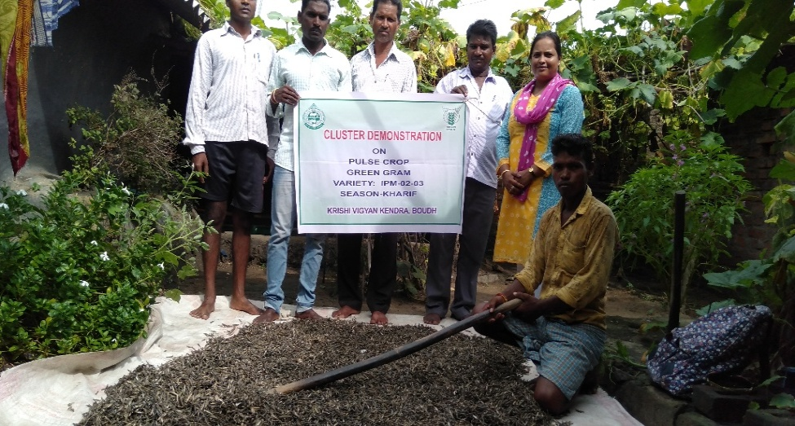
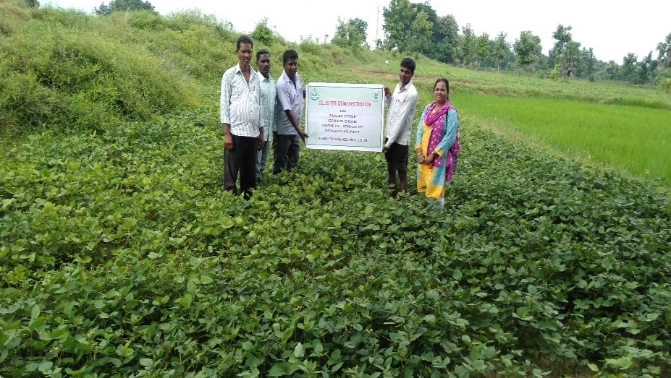
8. Sequential good quality photographs (as per crop stages i.e. growth &development)

Greengram at vegetative stage GreenGram at harvesting Stage
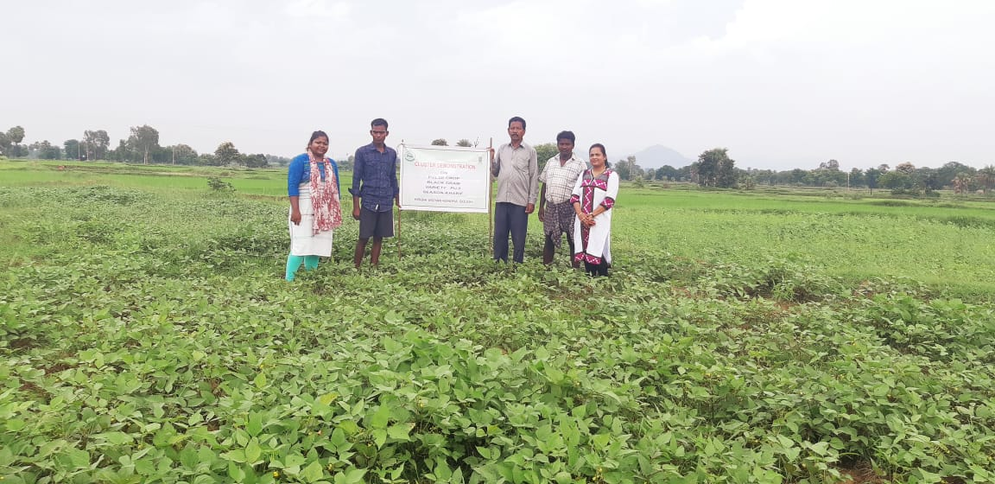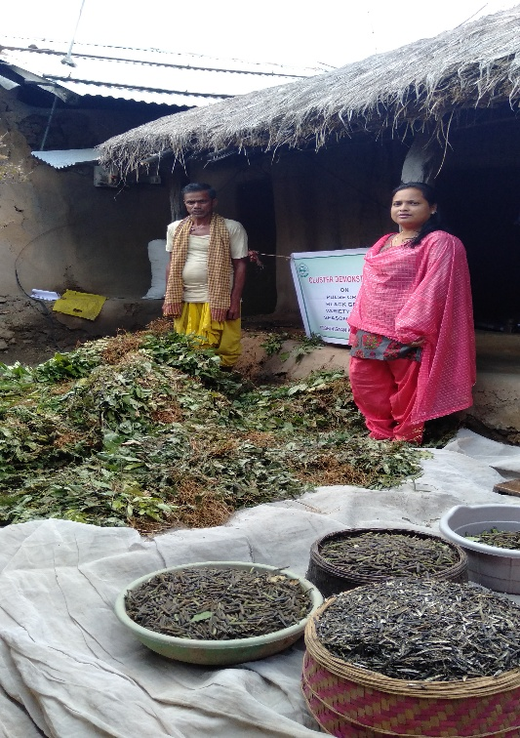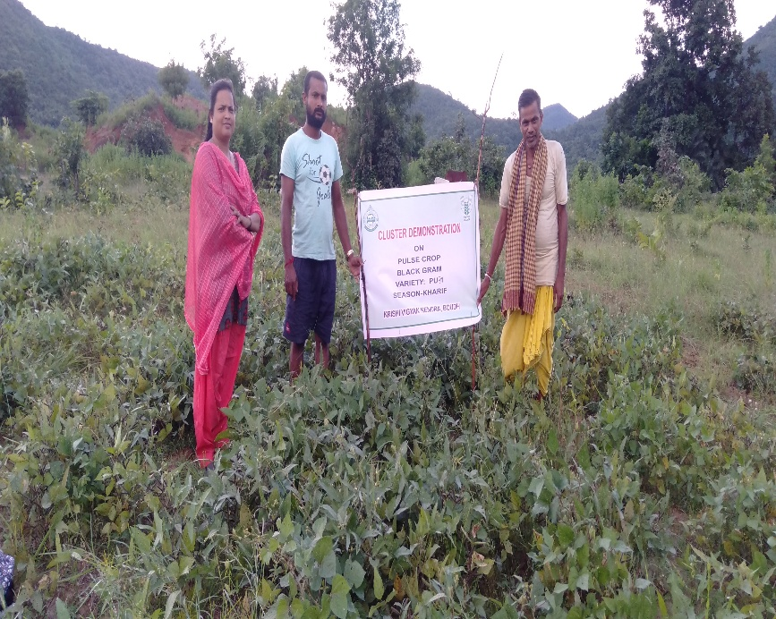

Black gram at vegetative stage Harvseting of Black gram Black gram at Harvesting stage

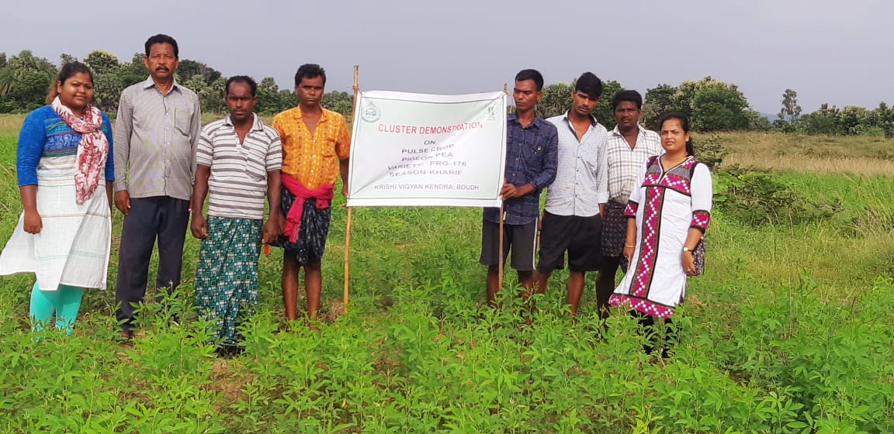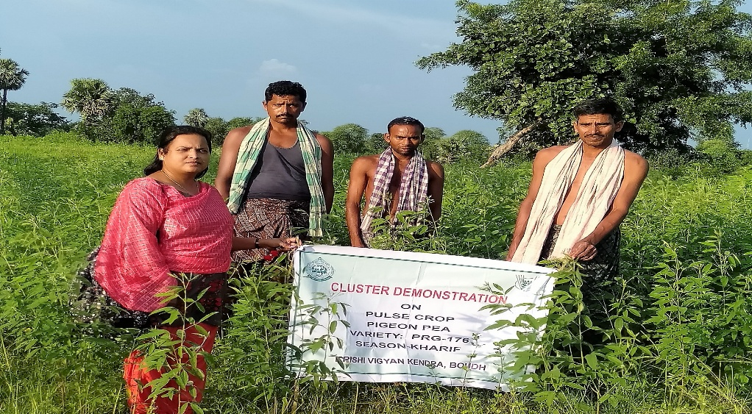
Pigeon Pea at Vegetative Stage
9. Farmers' training photographs
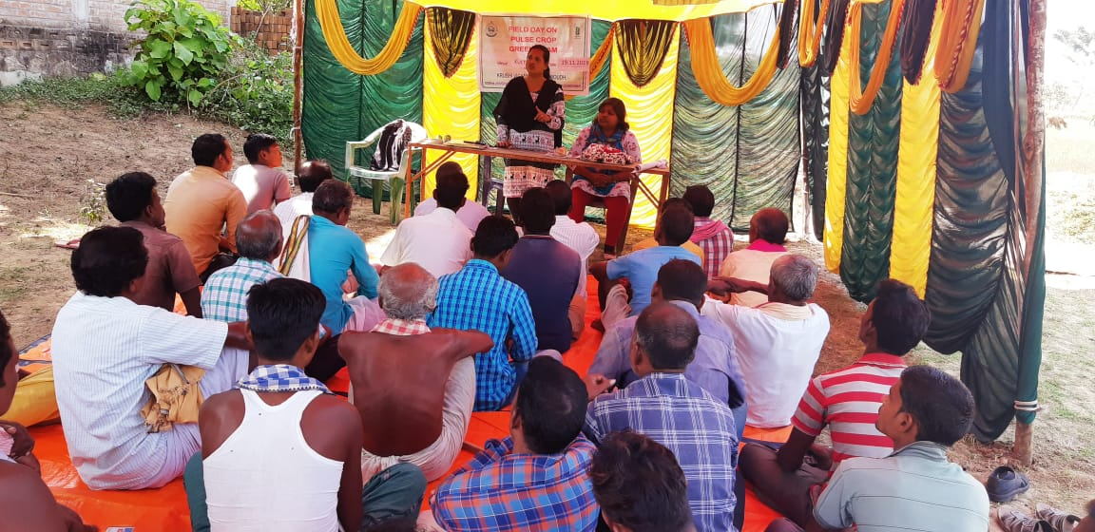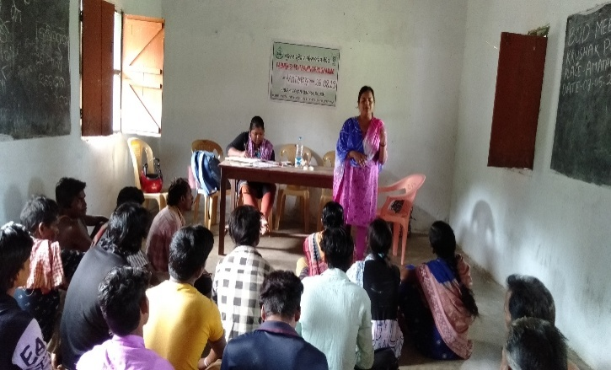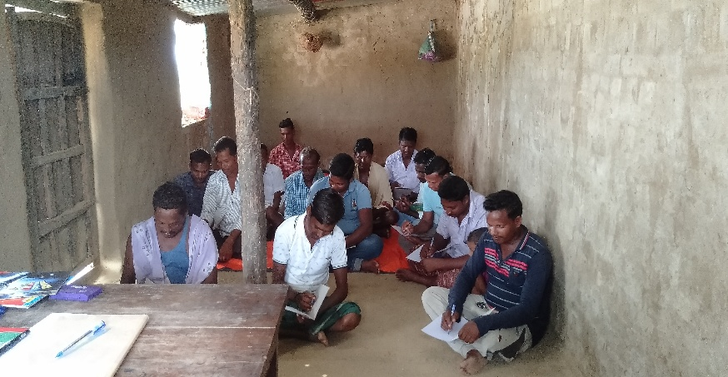
Field Day at Village-Kulutakhali
10. Quality Photographs of field visits/field days and technology demonstrated.
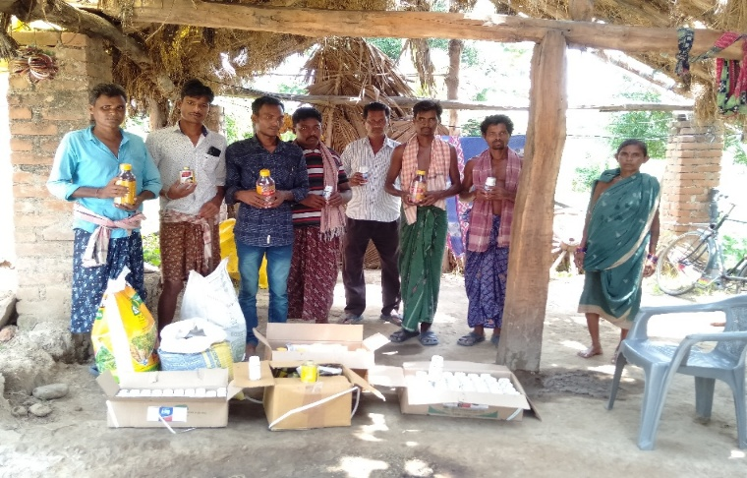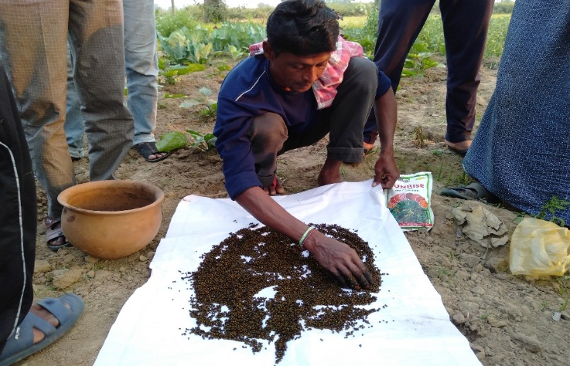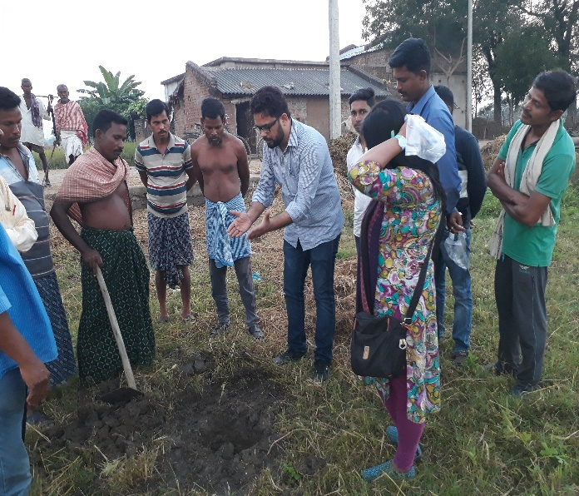
Rhizobium Treatment Soil sample collection

11. Details of budget utilization
Crop  (provide crop wise information ) | Items | Budget  Received  (Rs.) | Budget  Utilization  (Rs.) | Balance  (Rs.)
 | i) Critical input | 2,70,000/- | 2,34,170 | Nil
 | ii) TA/DA/POL etc. for monitoring |  | 8580
 | iii) Extension Activities (Field day) |  | 11250
 | iv)Publication of literature |  | 16000
 | Total

12. List of Farmer under FLD (Crop wise)

- Crop1 (Arhur)
Name of farmer | Father’s name | Village | Block | Mobile No. | Email ID | GPS Coordinates (DDMMSS format) |  | Soil testing done (Yes/No) |  | Recommendations based on soil test value | Brief technology intervention | Variety | Seed quantity used | Demo. Yield (q/ha) |  |  | Yield of local check q/ha | % increase
 |  |  |  |  |  | Latitude | Longitude |  |  |  |  |  |  | H | L | A
Rabindra Ku. Deo | Krushna Ch. Deo | Kulutakhali  Palaspat  boudh | Boudh | 9938573619 |  | 20°48'21.282" | 84°11'02.452" | Yes |  | Urea(11.8 kg/ha), DAP(108.7 kg/ha), MOP(33.3 kg/ha) | Variety, Herbicides, plant protection measures | PRG-176 | 8 Kg | 14.0 | 11.8 | 13.5 | 9.96 | 26.2
Ananta Sul | Padma Sul | -do- | Boudh | 8018715486 |  | 20°48'21.034" | 84°11'02.896" | Yes |  | Do | Do | PRG-176 | 8 Kg | 14.0 | 11.8 | 13.5 | 9.96 | 26.2
Hrudananda Kheti | Maheswari Kheti | -do- | Boudh |  |  | 20°48'21.486" | 84°11'02.334" | Yes |  | Do | Do | PRG-176 | 8 Kg | 14.0 | 11.8 | 12.8 | 9.96 | 22.2
Sushanta Ku. Kheti | Himanshu Kheti | -do- | Boudh |  |  | 20°48'21.591" | 84°11'02.748" | Yes |  | Do | Do | PRG-176 | 8 Kg | 14.0 | 11.8 | 13.8 | 9.96 | 27.8
Arat Bhoi | Dharani Bhoi | -do- | Boudh |  |  | 20°48'21.301" | 84°11'02.625" | Yes |  | Do | Do | PRG-176 | 8 Kg | 14.0 | 11.8 | 14 | 9.96 | 28.9
Tripurari Podh | Goura Podh | -do- | Boudh |  |  | 20°48'21.212" | 84°11'02.192" | Yes |  | Do | Do | PRG-176 | 8 Kg | 14.0 | 11.8 | 13.5 | 9.96 | 26.2
Bansidhara Podh | Saraju Podh | -do- | Boudh |  |  | 20°48'21.791" | 84°11'02.258" | Yes |  | Do | Do | PRG-176 | 8 Kg | 14.0 | 11.8 | 12.8 | 9.96 | 22.2
Uadhabha Podh | Akura Podh | -do- | Boudh |  |  | 20°48'21.901" | 84°11'02.245" | Yes |  | Do | Do | PRG-176 | 8 Kg | 14.0 | 11.8 | 13.7 | 9.96 | 27.3
Himanshu Ksheti | Satrughna Ksheti | -do- | Boudh |  |  | 20°48'21.612" | 84°11'02.022" | Yes |  | Do | Do | PRG-176 | 8 Kg | 14.0 | 11.8 | 12.9 | 9.96 | 22.8
Pabitra Podh | Saruja Podh | -do- | Boudh |  |  | 20°48'21.101" | 84°11'02.245" | Yes |  | Do | Do | PRG-176 | 8 Kg | 14.0 | 11.8 | 13.7 | 9.96 | 27.3
Nirakar Pradhan | Akhaya Pradhan | Ereda | Boudh | 9777711226 |  | 20˚45.278 | 84˚15.412 | Yes |  | Do | Do | PRG-176 | 8 Kg | 14.0 | 11.8 | 12.5 | 9.96 | 20.3
Prakash Pradhan | Dakhya Pradhan | -do- | Boudh | 7749012271 |  | 20˚45.492 | 84˚15.432 | Yes |  | Do | Do | PRG-176 | 8 Kg | 14.0 | 11.8 | 13.4 | 9.96 | 25.7
Pramod Ku. Pradhan | Suresh Pradhan | -do- | Boudh | 8457986296 |  | 20˚45.586 | 84˚15.616 | Yes |  | Do | Do | PRG-176 | 8 Kg | 14.0 | 11.8 | 13.5 | 9.96 | 26.2
Pramod Ku. Bhoi | Narendra Bhoi | -do- | Boudh | 7894664341 |  | 20˚45.652 | 84˚15.446 | Yes |  | Do | Do | PRG-176 | 8 Kg | 14.0 | 11.8 | 13.2 | 9.96 | 24.5
Ganeswar Sahu | Baji Sahu | -do- | Boudh | 9668855440 |  | 20˚45.321 | 84˚15.672 | Yes |  | Do | Do | PRG-176 | 8 Kg | 14.0 | 11.8 | 13.4 | 9.96 | 25.7
Rabindra Mallick | Kazteswar Mallick | -do- | Boudh | 9668009789 |  | 20˚45.486 | 84˚15.424 | Yes |  | Do | Do | PRG-176 | 8 Kg | 14.0 | 11.8 | 13.5 | 9.96 | 26.2
Laxman Sahu | Indra Sahu | -do- | Boudh | 7655057866 |  | 20˚45.261 | 84˚15.124 | Yes |  | Do | Do | PRG-176 | 8 Kg | 14.0 | 11.8 | 12.4 | 9.96 | 19.7
Dillip ku. Sahu | Sambha Prasad Sahu | -do- | Boudh | 8658286778 |  | 20˚45.476 | 84˚15.438 | Yes |  | Do | Do | PRG-176 | 8 Kg | 14.0 | 11.8 | 13.5 | 9.96 | 26.2
Trilochan Bhoi | Daitari Bhoi | -do- | Boudh | 9938310298 |  | 20˚45.234 | 84˚15.112 | Yes |  | Do | Do | PRG-176 | 8 Kg | 14.0 | 11.8 | 14 | 9.96 | 28.9
Chakradhar Pradhan | Utsaba Pradhan | -do- | Boudh | 9556999522 |  | 20˚45.625 | 84˚15.482 | Yes |  | Do | Do | PRG-176 | 8 Kg | 14.0 | 11.8 | 12.8 | 9.96 | 22.2
Suman Pradhan | Gupteswar Pradhan | -do- | Boudh | 8018492778 |  | 20˚45.782 | 84˚15.632 | Yes |  | Do | Do | PRG-176 | 8 Kg | 14.0 | 11.8 | 14 | 9.96 | 28.9
Sitaram Naik | Sahadeb Naik | -do- | Boudh | 7327093967 |  | 20˚45.214 | 84˚15.472 | Yes |  | Do | Do | PRG-176 | 8 Kg | 14.0 | 11.8 | 12.8 | 9.96 | 22.2
Pabitra Sahu | Rajkishore Sahu | -do- | Boudh | 342118935194 |  | 20˚45.521 | 84˚15.332 | Yes |  | Do | Do | PRG-176 | 8 Kg | 14.0 | 11.8 | 13.9 | 9.96 | 28.3
Jagabandhu Sahu | Ganeswar Sahu | Palaspat | Boudh |  |  | 20°48'21.451" | 84°11'02.325" | Yes |  | Do | Do | PRG-176 | 8 Kg | 14.0 | 11.8 | 13.9 | 9.96 | 28.3
Ranka Ku. Dhal | Lokeyi Dhal | Palaspat | Boudh |  |  | 20°48'21.892" | 84°11'02.692" | Yes |  | Do | Do | PRG-176 | 8 Kg | 14.0 | 11.8 | 13.2 | 9.96 | 24.5
CROP 2 Greengram var. IPM 02-03

Tapisa Naik | w/o.Hara Naik | Amthapada | Boudh |  |  | 20°41'43.411" | 84°14'44.814" | Yes |  |  | Use of HYV(IPM-02-03)Seed treatment with carboxin+ thiram; Application of herbicides(pendimethalin 2.5 lit/ha  Application of Imidacloprid @0.4 ml/lit control sucking pests | IPM-02-03 | 8 Kg | 7.0 | 5.7 | 6.2 | 5.7 | 8.77
Mera Naik | Kasthu Mirdha | -do- | Boudh |  |  | 20°41'43.658" | 84°14'44.152" | Yes | Do |  |  | IPM-02-03 | 8 Kg | 7.0 | 5.7 | 5.8 | 5.7 | 1.75
Manta Panigiri | Dibadhan Behera | -do- | Boudh |  |  | 20°41'43.711" | 84°14'44.139 | Yes | Do |  |  | IPM-02-03 | 8 Kg | 7.0 | 5.7 | 6.9 | 5.7 | 21.1
Gurubari Mirdha | Ganga Naik | -do- | Boudh |  |  | 20°41'43.616" | 84°14'44.124" | Yes | Do |  |  | IPM-02-03 | 8 Kg | 7.0 | 5.7 | 6 | 5.7 | 5.26
Minakshi Naik | Baistha Mukhi | -do- | Boudh |  |  | 20°41'43.559" | 84°14'44.145" | Yes | Do |  |  | IPM-02-03 | 8 Kg | 7.0 | 5.7 | 6.2 | 5.7 | 8.77
Mira Panigiri | Bichhindra Naik | -do- | Boudh |  |  | 20°41'43.175" | 84°14'44.220" | Yes | Do |  |  | IPM-02-03 | 8 Kg | 7.0 | 5.7 | 6.8 | 5.7 | 3.51
Gitanjali Danayak |  | -do- | Boudh | 9938573619 |  | 20°41'43.407" | 84°14'44.873" | Yes | Do |  | Do | IPM-02-03 | 8 Kg | 7.0 | 5.7 | 6.5 | 5.7 | 14
Sumitra Panigri | Ude Naik | -do- | Boudh | 8018715486 |  | 20°41'43.282" | 84°14'44.735" | Yes | Do |  | Do | IPM-02-03 | 8 Kg | 7.0 | 5.7 | 6.2 | 5.7 | 8.77
Soundhi Naik | Laksha Mirdha | -do- | Boudh |  |  | 20°41'43.182" | 84°14'44.521" | Yes | Do |  | Do | IPM-02-03 | 8 Kg | 7.0 | 5.7 | 6.8 | 5.7 | 19.3
Kumadini Naik | Sukra Mirdha | -do- | Boudh |  |  | 20°41'43.321" | 84°14'44.306" | Yes | Do |  | Do | IPM-02-03 | 8 Kg | 7.0 | 5.7 | 6.8 | 5.7 | 19.3
Bila Naik | Raghu Naik | -do- | Boudh |  |  | 20°41'43.411" | 84°14'44.814" | Yes | Do |  | Do | IPM-02-03 | 8 Kg | 7.0 | 5.7 | 6.8 | 5.7 | 19.3
Sapura Panigiri | Goura Panigiri | -do- | Boudh |  |  | 20°41'43.521" | 84°14'44.826" | Yes | Do |  | Do | IPM-02-03 | 8 Kg | 7.0 | 5.7 | 6.8 | 5.7 | 19.3
Sushanta Ku. Ksheti | Himanshu Ksheti | Kulutakhali  Palashpat | Boudh |  |  | 20°48'21.282" | 84°11'02.652" | Yes | Do |  | Do | IPM-02-03 | 8 Kg | 7.0 | 5.7 | 6.8 | 5.7 | 19.3
Sumansu Ksheti | Satrughan Ksheti | -do- | Boudh |  |  | 20°48'21.034" | 84°11'02.096" | Yes | Do |  | Do | IPM-02-03 | 8 Kg | 7.0 | 5.7 | 7 | 5.7 | 22.8
Basu Ranbida | Senapati Ranbida | -do- | Boudh |  |  | 20°48'21.130" | 84°11'02.534" | Yes | Do |  | Do | IPM-02-03 | 8 Kg | 7.0 | 5.7 | 7 | 5.7 | 22.8
Mana Muduli | Baishnab Muduli | -do- | Boudh |  |  | 20°48'21.891" | 84°11'02.248" | Yes | Do |  | Do | IPM-02-03 | 8 Kg | 7.0 | 5.7 | 7 | 5.7 | 22.8
Premananda Bhanja | Basanta Bhanja | -do- | Boudh |  |  | 20°48'21.401" | 84°11'02.225" | Yes | Do |  | Do | IPM-02-03 | 8 Kg | 7.0 | 5.7 | 7 | 5.7 | 22.8
Sankirttan Ranbida | Senapati Ranbida | -do- | Boudh |  |  | 20°48'21.812" | 84°11'02.092" | Yes | Do |  | Do | IPM-02-03 | 8 Kg | 7.0 | 5.7 | 6.8 | 5.7 | 19.3
Tripurari Nayak | Rameswar Nayak | Badhigaon  Olanda | Boudh | 8018676009 |  | 20˚48.781 | 84˚15.252 | Yes | Do |  | Do | IPM-02-03 | 8 Kg | 7.0 | 5.7 | 6.8 | 5.7 | 19.3
Tikilal Nayak | Kedar Nath Nayak | -do- | Boudh | 7894536511 |  | 20˚48.781 | 84˚15.252 | Yes | Do |  | Do | IPM-02-03 | 8 Kg | 7.0 | 5.7 | 6.8 | 5.7 | 19.3
Laxmidhara  Nayak | Rameswar Nayak | -do- | Boudh | 7894899688 |  | 20˚48.781 | 84˚15.252 | Yes | Do |  | Do | IPM-02-03 | 8 Kg | 7.0 | 5.7 | 6.8 | 5.7 | 19.3
Bipin Bihari Pradhan | Jadunath Pradhan | -do- | Boudh |  |  | 20˚48.781 | 84˚15.252 | Yes | Do |  | Do | IPM-02-03 | 8 Kg | 7.0 | 5.7 | 6.8 | 5.7 | 19.3
Pabitra Swain | Rushi Swain | -do- | Boudh |  |  | 20˚48.781 | 84˚15.252 | Yes | Do |  | Do | IPM-02-03 | 8 Kg | 7.0 | 5.7 | 6.9 | 5.7 | 21.1
Taranisen Bagh | Ekadashi Bagh | -do- | Boudh |  |  | 20˚48.781 | 84˚15.252 | Yes | Do |  | Do | IPM-02-03 | 8 Kg | 7.0 | 5.7 | 6 | 5.7 | 5.26
Sarat Pradhan | Raghunath Pradhan | -do- | Boudh |  |  | 20˚48.781 | 84˚15.252 | Yes | Do |  | Do | IPM-02-03 | 8 Kg | 7.0 | 5.7 | 6.2 | 5.7 | 8.77
Crop-3-BlackGram-PU-31
Rabindra Ku. Deo | Krushna Ch. Deo | Kulutakhali  Palaspat | Boudh |  |  | 20°48'21.582" | 84°11'02.252" |  | Urea(20.3 kg/ha), DAP(87.0 kg/ha), MOP(33.3 kg/ha) |  | Variety, Herbicides, plant protection measures | PU-31 | 8 kg | 7.0 | 5.7 | 6.2 | 5.7 | 8.77
Ananta Sul | Padma Sul | -do- | Boudh |  |  | 20°48'21.334" | 84°11'02.496" | Yes | Do |  | Do | PU-31 | 8 kg | 7.0 | 5.7 | 5.8 | 5.7 | 1.75
Hrudananda Kheti | Maheswari Kheti | -do- | Boudh |  |  | 20°48'21.286" | 84°11'02.354" | Yes | Do |  | Do | PU-31 | 8 kg | 7.0 | 5.7 | 6.9 | 5.7 | 21.1
Sushanta Ku. Kheti | Himanshu Kheti | -do- | Boudh |  |  | 20°48'21.191" | 84°11'02.788" | Yes | Do |  | Do | PU-31 | 8 kg | 7.0 | 5.7 | 6 | 5.7 | 5.26
Arat Bhoi | Dharani Bhoi | -do- | Boudh |  |  | 20°48'21.321" | 84°11'02.645" | Yes | Do |  | Do | PU-31 | 8 kg | 7.0 | 5.7 | 6.2 | 5.7 | 8.77
Tripurari Podh | Goura Podh | -do- | Boudh |  |  | 20°48'21.242" | 84°11'02.792" | Yes | Do |  | Do | PU-31 | 8 kg | 7.0 | 5.7 | 5.9 | 5.7 | 3.51
Bansidhara Podh | Saraju Podh | -do- | Boudh |  |  | 20°48'21.751" | 84°11'02.288" | Yes | Do |  | Do | PU-31 | 8 kg | 7.0 | 5.7 | 5.9 | 5.7 | 3.51
Uadhabha Podh | Akura Podh | -do- | Boudh |  |  | 20°48'21.911" | 84°11'02.295" | Yes | Do |  | Do | PU-31 | 8 kg | 7.0 | 5.7 | 6.2 | 5.7 | 8.77
Himanshu Ksheti | Satrughna Ksheti | -do- | Boudh |  |  | 20°48'21.622" | 84°11'02.072" | Yes | Do |  | Do | PU-31 | 8 kg | 7.0 | 5.7 | 5.8 | 5.7 | 1.75
Pabitra Podh | Saruja Podh | -do- | Boudh |  |  | 20°48'21.121" | 84°11'02.295" | Yes | Do |  | Do | PU-31 | 8 kg | 7.0 | 5.7 | 6.2 | 5.7 | 8.77
Prafulla ku. Sahu | Sambhu Prasad Sahu | Ereda, Salunki | Boudh |  |  | 20˚45.228 | 84˚15.485 | Yes | Do |  | Do | PU-31 | 8 kg | 7.0 | 5.7 | 6.2 | 5.7 | 8.77
Maheswar Sahu | Meghu | -do- | Boudh |  |  | 20˚45.452 | 84˚15.732 | Yes | Do |  | Do | PU-31 | 8 kg | 7.0 | 5.7 | 6.1 | 5.7 | 7.02
Meghu Sahu | Sudra Sahu | -do- | Boudh |  |  | 20˚45.546 | 84˚15.616 | Yes | Do |  | Do | PU-31 | 8 kg | 7.0 | 5.7 | 6.7 | 5.7 | 17.5
Narottam Singh | Birabar singh | -do- | Boudh |  |  | 20˚45.622 | 84˚15.486 | Yes | Do |  | Do | PU-31 | 8 kg | 7.0 | 5.7 | 6.8 | 5.7 | 19.3
Promad Ku. Singh | Nabin Ku. Singh | -do- | Boudh |  |  | 20˚45.351 | 84˚15.972 | Yes | Do |  | Do | PU-31 | 8 kg | 7.0 | 5.7 | 6.2 | 5.7 | 8.77
Krushna Ch. Pradhan | Chandra Pradhan | -do- | Boudh |  |  | 20˚45.496 | 84˚15.824 | Yes | Do |  | Do | PU-31 | 8 kg | 7.0 | 5.7 | 5.8 | 5.7 | 1.75
Udayanath Beriha | Hrushi kesh beriha | -do- | Boudh |  |  | 20˚45.231 | 84˚15.184 | Yes | Do |  | Do | PU-31 | 8 kg | 7.0 | 5.7 | 6.9 | 5.7 | 21.1
Prakash Pradhan | Surendra Pradhan | -do- | Boudh |  |  | 20˚45.416 | 84˚15.498 | Yes | Do |  | Do | PU-31 | 8 kg | 7.0 | 5.7 | 6 | 5.7 | 5.26
Chandra Pradhan | Sribaascha Pradhan | -do- | Boudh |  |  | 20˚45.734 | 84˚15.312 | Yes | Do |  | Do | PU-31 | 8 kg | 7.0 | 5.7 | 6.2 | 5.7 | 8.77
Jhili Pradhan | Alekha Pradhan | -do- | Boudh |  |  | 20˚45.645 | 84˚15.782 | Yes | Do |  | Do | PU-31 | 8 kg | 7.0 | 5.7 | 6.8 | 5.7 | 3.51
Girish ch. Pradhan | Akrura Pradhan | Kanakpur | Boudh |  |  | 20°41'43.496" | 84°14'44.528" | Yes | Do |  | Do | PU-31 | 8 kg | 7.0 | 5.7 | 6.5 | 5.7 | 14
Ashok Pradhan | Duryan Pradhan | -do- | Boudh |  |  | 20°41'43.446" | 84°14'44.728" | Yes | Do |  | Do | PU-31 | 8 kg | 7.0 | 5.7 | 6.2 | 5.7 | 8.77
Dhanamali Sahoo | Gupteswar Sahoo | -do- | Boudh |  |  | 20°41'43.452" | 84°14'44.828" | Yes | Do |  | Do | PU-31 | 8 kg | 7.0 | 5.7 | 6.8 | 5.7 | 19.3
Baruna Ku. Sahu | Alekha Sahu | -do- | Boudh |  |  | 20°41'43.410" | 84°14'44.228" | Yes | Do |  | Do | PU-31 | 8 kg | 7.0 | 5.7 | 6.8 | 5.7 | 19.3
Gokulananda Pradhan | Akura Pradhan | -do- | Boudh |  |  | 20°41'43.494" | 84°14'44.928" | Yes | Do |  | Do | PU-31 | 8 kg | 7.0 | 5.7 | 6.8 | 5.7 | 19.3

___________________________ _______________________
Signature of Head of Organization Signature of Programme Co-coordinator

