Special Campaign 5.0 [2nd – 31st Oct. 2025]
Pendency Identification and Achievement Status Form

Name of the Organization/Unit: - KVK, Boudh, OUAT, Bhubaneswar
Information as on date: 31.10.2025
A. Total Pending references identified & Achievement thereof
 | Pendency as on 25.09.25 | Received after 25.09.25* | Disposed After 25.09.25* | Remarks
References of MPs/VIPs | Nil | 01 | 01 | By all the Divisions
IMC References | Nil | Nil | Nil | By DARE (IC-I)
Public Grievances | 01 | 05 | 05 | By all the Divisions
Parliamentary Assurances | Nil | Nil | Nil | By Parl. Section
State Government References | Nil | Nil | Nil | By all the Divisions
PMO References | 04 | 12 | 16 | By all the Divisions
B. Target for Record Management during the Special Campaign (2nd – 31st Oct. 2025)
i. Physical Files
Target for number of files to be reviewed | Total physical files reviewed after 25.09.25* | Files transferred to NAI after 25.9.25* | Total no. of files identified for weeding after 25.9.25* | Total no. of physical files weeded out after 25.09.25* | By all the Divisions
03 | 17 | Nil | 09 | 09 | -

ii. E-Files
Target for number of e-files to be reviewed | Total number of E-files closed after 25.09.25* | By all the Divisions
15 | 10 | By all the Divisions

C. Cleanliness & Official Scrap Disposal
i. INDOOR
System in Place  (Yes/No) | Inspection Architecture in Place  (Yes/No.) | Outsource Agency Deployed  (Yes No.) | Level of Inspecting Officer  (US/DS/Director) | By all the Divisions
Yes | No | No | Sr. Scientist & Head  Central Head, NHRDF | By all the Divisions

ii. OUTDOOR- Number of Campaigns during the Special Campaign (2nd – 31st Oct. 2025)
Target for total number of campaigns to be conducted | Total campaign conducted after 25.09.25* | Highest Leading Level of Any Campaign
06 | 06 | Sr. Scientist & Head  Dy. Director, NHRDF
(Please send two photographs of each such campaign site clearing mentioning before and after conducting the campaign)
iii. OFFICE SCRAP DISPOSAL during the Special Campaign (2nd – 31st Oct. 2025)
Item | Target | Achievement after 25.09.2025* | By all the Divisions
Space (Sq. ft.) | Nil | Nil | By all the Divisions
Revenue to be generated (Rs.) | Nil | Nil | By all the Divisions
Approx. Quantity (in tonnage) | Nil | Nil | By all the Divisions

D. EASING OF RULES/PROCESSES
Numbers of Rules Identified for Simplification | Number of Rules Simplified after 25.09.25 | By all the Divisions
03 | 03

E. PUBLIC GRIEVANCE APPEALS

Pendency as on 25.09.2025 | Received After 25.09.2025* | Disposed after 25.09.25* | By ICT Division
01 | 07 | 07 | By ICT Division
*On Cumulative basis
F. DETAILS OF SITES HAVING MAXIMUM POSSIBLE IMPACT OF THE CAMPAIGN
Name of  the site | Location | Before and After Photographs | By all the  Divisions
KVK  Campus,  Boudh | Paljhar,  Boudh
  Before Photos | After Photos
  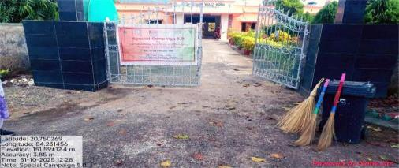 | 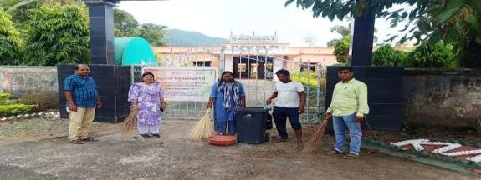
  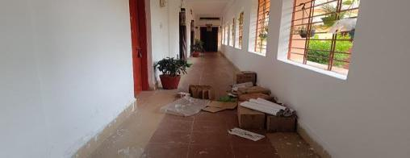 | 
  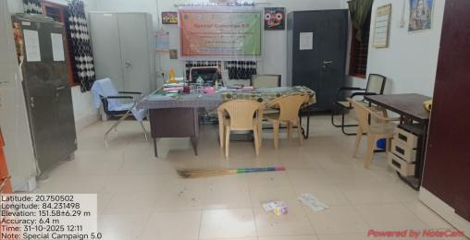 | 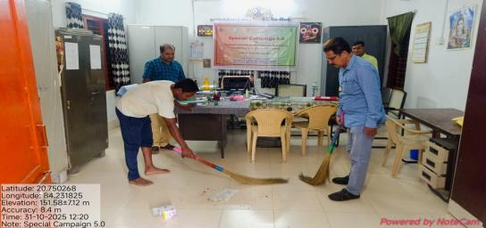
  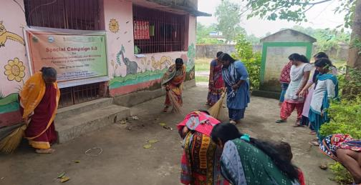 | 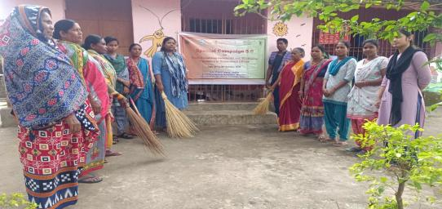
  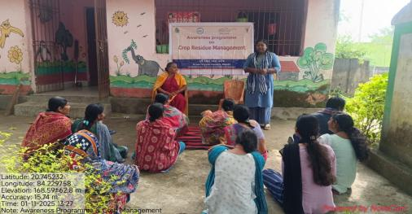 | 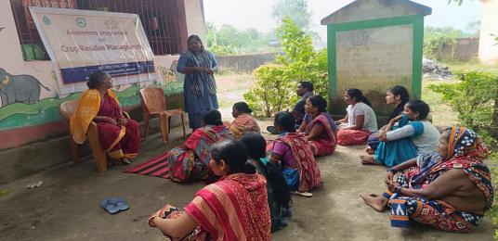
  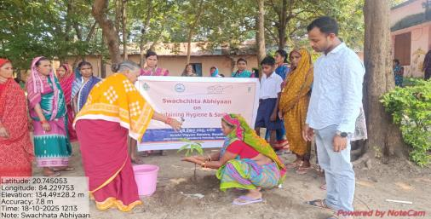 | 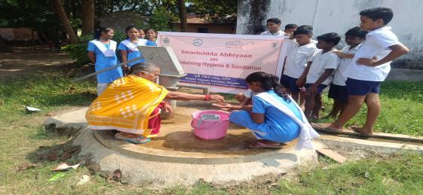

Sd/-
Sr. Scientist & Head
KVK, Boudh

