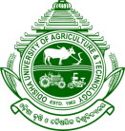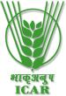
Report on Rastriya Ekta Diwas 2025
Name of the KVK: Krishi Vigyan kendra, Boudh
Date: 31st October, 2025
Venue: KVK Campus and Kalyani Mandap, Kantamal, Boudh.

Rashtriya Ekta Diwas (National Unity Day) was observed by KVK, Boudh on 31st October 2025 to commemorate the birth anniversary of Sardar Vallabhbhai Patel, the Iron Man of India. On this occasion all official Staff of KVK, farmers, and students of Agro polytechnic Centre, Boudh took the Unity Pledge reaffirming their commitment to national unity, integrity, and security and participated in awareness meeting emphasizing national integration and collective responsibility. An awareness meeting were organized on the KVK campus with the collage students to highlight the importance of togetherness and collective responsibility in nation-building. Sj. Tapan Kumar Das, Sr. Scientist & Head of KVK sensitized participants on the role of farmers and rural youth in strengthening social harmony and sustainable development. Afterthat other Scientists highlighted the importance of unity and cooperation for strengthening agriculture and rural development.
Following the pledge, short videos on ‘Ek Bharat, Shreshtha Bharat’ and the life and contributions of Sardar Vallabhbhai Patel were screened, highlighting the importance of unity, peace, and integrity in nation-building.
Under the leadership of SMS (Agril Extension) YCDA NGO collaborating with PRADAN organized a lecture session starting with the Unity pledge with the total 100 nos. Of Producer group members of Matrushakti FPO members at Kalyani Mandap, Kantamal block, Boudh on the same date. This was followed by an inspirational lecture on “Ek Bharat, Shreshtha Bharat” by Dr. Mayuri Sing Sardar, SMS(Agril Extension), who emphasized India’s strength in unity amidst diversity and highlighted Sardar Vallabhbhai Patel’s pivotal role in unifying the nation. A Unity Run was then organized within the Public places, with enthusiastic participation from all PG members, symbolizing solidarity and the spirit of oneness. The event concluded with a message on promoting unity through community participation and agricultural progress.
Report:
Farmers | Farm women | Collage Students | KVK staff | Other Official Staff | Total Participants
25 | 75 | 19 | 10 | 15 | 144

Photographs:
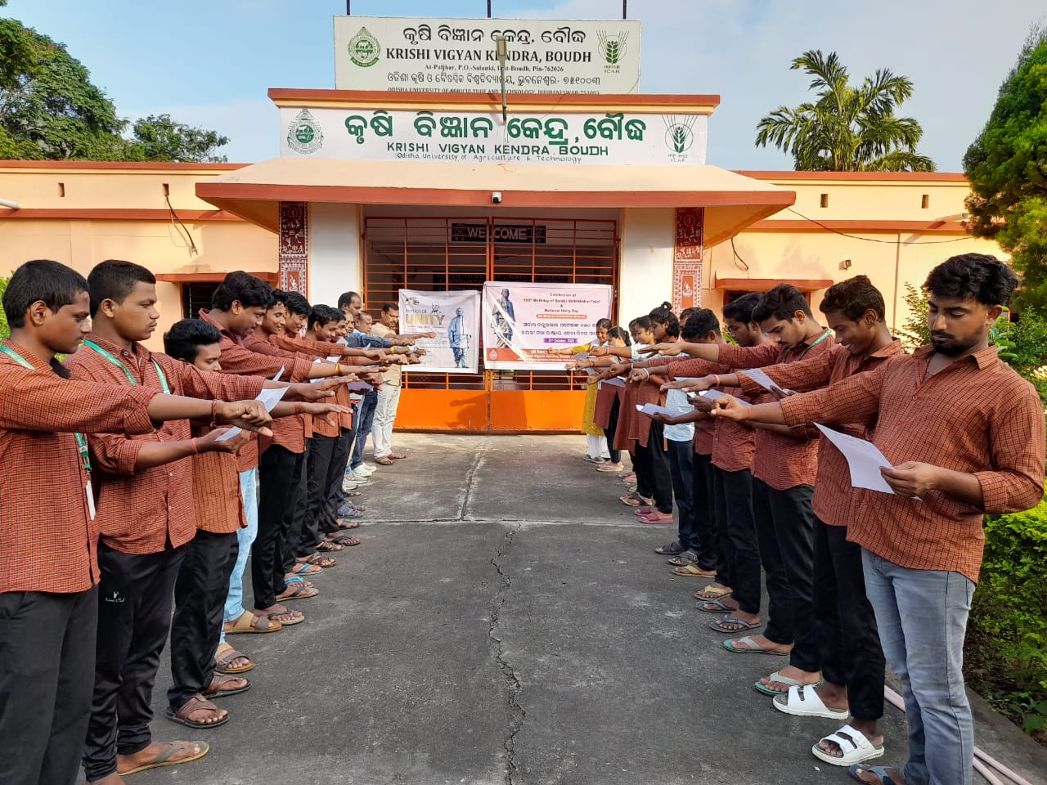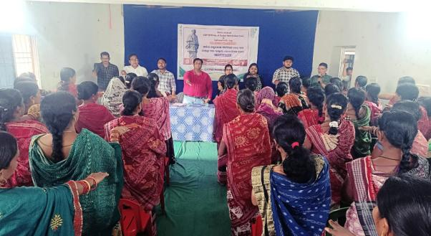
Unity pledge taken by all staffs and students
Unity pledge taken by all line dept. Officials and PG group members

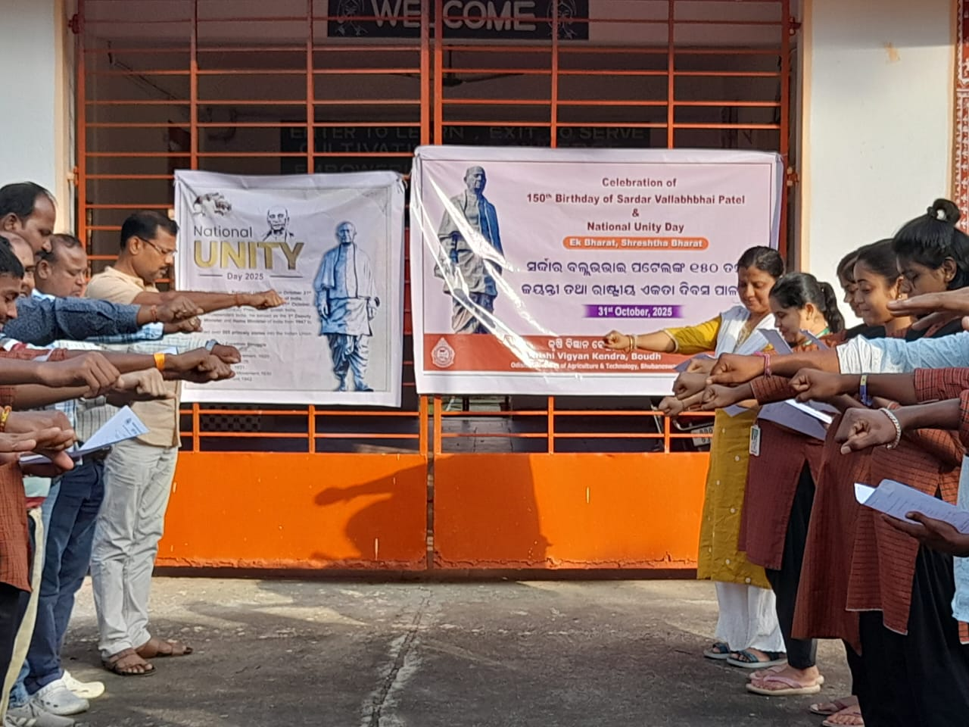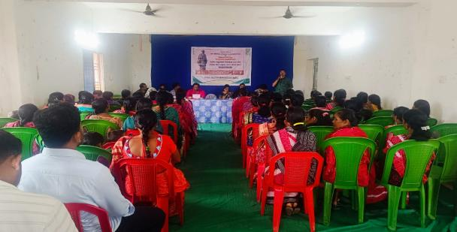
Organized a lecture on the Occasion of National Unity Day
Display of banner of The Iron Man of India at KVK

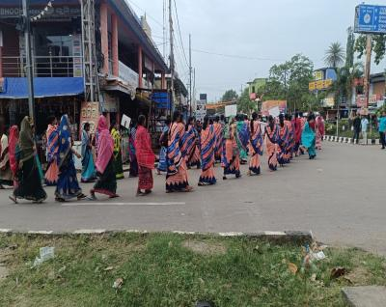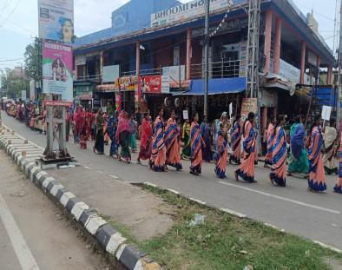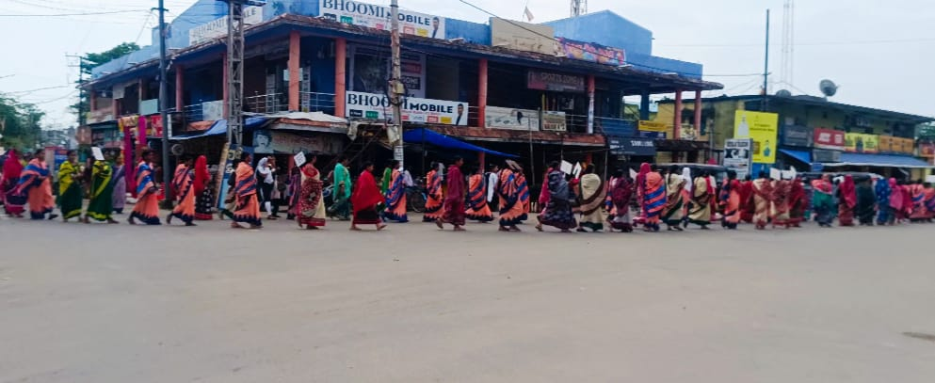
A unity run participated by all staffs, PG group members

Sd/-
Sr. Scientist & Head
KVK, Boudh

