Report on Date wise Action Plan for Swachhta Hi Sewa (with the theme Swachhtosav – स्वच्छोत्सव) during 17thSeptember to 02ndOctober, 2025
Name of KVK: Krishi Vigyan Kendra, Boudh
Sl.No. | Date | Activities | No. of Participants (Farmers/ Staffs/ other Participants) | No. of VVIPs/VIPs attended the program | Action photographs (2 - 3 nos)
1 | 17.09.2025 | - Display of banner at prominent places, taking Swachhata pledge, Swachhata pledge in offices, educational institutions, public spaces etc.  - Installation of selfie points at strategic locations.  - Organisation of Swachhata runs, cyclathons, and marathons to promote fitness and cleanliness through community participation.  - Organisation of Swachh Ward / Swachh Gram Panchayat Competition: Local bodies are encouraged to evaluate swachhata within their wards/Gram Panchayat including assessing innovative solutions, effectiveness of volunteer mobilization, and best practices. Categories such as “Best Overall Cleanliness,” “Most Innovative Waste Management Solutions,” & “Best Community Participation” can be used to recognize best performing wards/GPs, as per requirement.  - Organisation of plantation drive “Ek Ped MaaKe Naam,” along with beautification activities. | 68 | Nil | 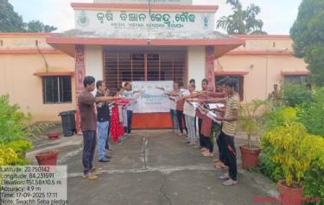  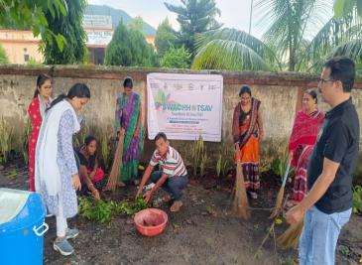  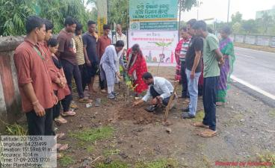  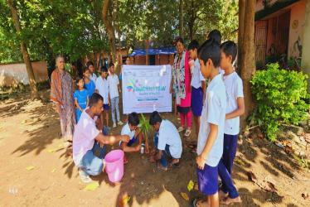  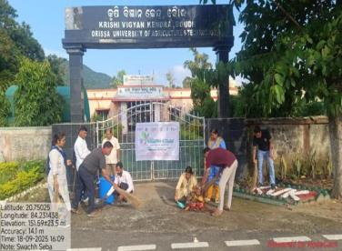
2 | 18.09.2025 | Transformation of Cleanliness Target Units (CTUs)  Difficult and dirty spots (black spots) will be identified, mapped, and cleared in a time-bound manner. Black spots are generally neglected garbage point that are difficult to clean as part of regular Swachhata drives and pose significant environmental, health, and hygiene risks.  - Identification of black spots  - Mapping on the SHS 2025 Portal  - Adoption of CTU sites  - Site preparedness & Execution  - Declaration of clearance by 1st October  - Site transformation and maintenance  The transformed CTU sites will be showcased and celebrated on 2nd October, 2025, as part of Swachh Bharat Diwas. | Nil | Nil | Nil
3 | 19.09.2025 | - Organisation of poetry, essay, painting, and poster competitions in educational institutions,schools,and Anganwadi Centres.  - Conduct of slogan-writing competitions, quizzes, and jingles related to the Swachh Bharat Mission (SBM) to engage younger audiences and raise awareness.  - Carryingoutofwallpaintingandbeautificationactivitiesatparks,high-footfalltourist points, roads, and flyovers.  - Conduct of Swachhata Quizzes at schools–Interactivecompetitionstestingstudents’ knowledge and awareness about cleanliness and sanitation.  - Hosting of Swachhata Class/Swachhata Ki Pathshaala–Educational sessions and workshops at schools to teach students about cleanliness, sanitation, and hygiene practices. | 35 | Nil | 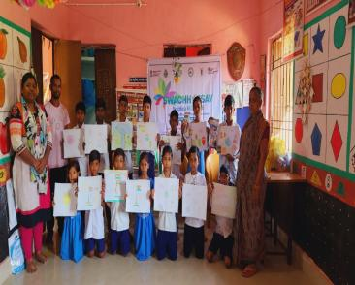  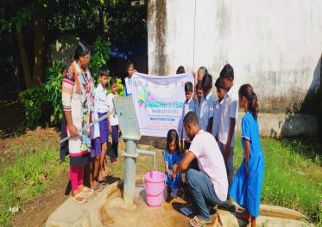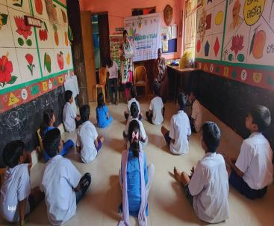
4 | 20.09.2025 | - Organisation of Swachh Sujal Gaon,Waste to Art, Clean Street Food,etc.–Initiativesto raise awareness and promote best practices in cleanliness and hygiene.  - Arrangement of Swachhata Samvad–Dialogues and discussions to engage communities and enhance participation in cleanliness initiatives.  - Organisation of Street Plays / Nukkad Nataks– Performances in local areas to educate and entertain while promoting sanitation and cleanliness.  - Arrangement of Educational Public Demonstrations–Practical demonstrations on hygiene, waste management, and sustainable practices.  - Organisation of Zero Waste Events – Activities to encourage minimal waste generation and sustainable practices.  - Mobilisation of NGOs and SHGs – Engaging local NGOs and Self-Help Groups to support Swachhata initiatives.  - Organisation of Outreach Campaigns for Swachhata–Community engagement activities to increase awareness and participation at the grassroots level. | 110 | Nil | 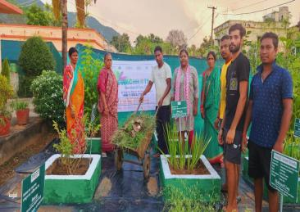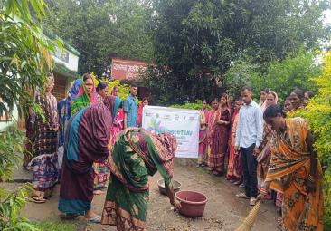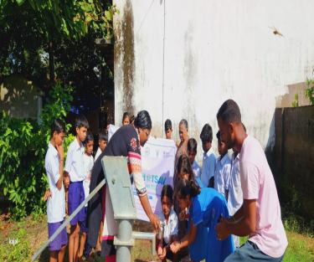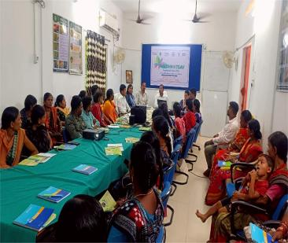
5 | 21.09.2025 | Safai Mitra Suraksha Shivirs  - Organisation of preventive health check ups as part of theShivirs/Campstobenefitsanitation workers and their families.  - Facilitation of linkage with welfare schemestoensureaccesstosocialandhealthbenefitsfor sanitation workers and their dependents | Nil | Nil | Nil
6 | 22.09.2025 | Human Chain  - Organisation of symbolic human chain events where people join hands to raise awareness and demonstrate commitment to cleanliness and sanitation.  - Conduct of ‘Reduce, Reuse, Recycle’activities aligned with Mission LiFE (Lifestyle for Environment) to promote sustainable practices. | 60 | Nil | 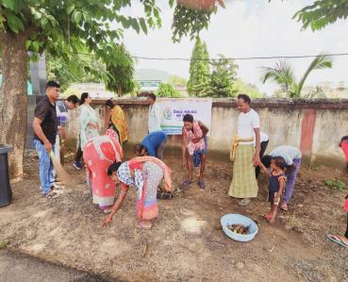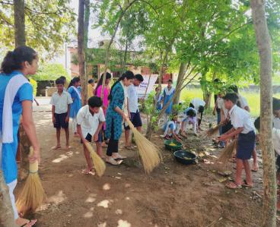
7 | 23.09.2025 | Clean Green Utsav  Organisation of eco-friendly and zero-waste celebrations integratingcitizen participation and partner mobilization to tackle general Swachhata challenges across local bodies.  Carryingoutofcleaningactivities in:  - Offices and institutional buildings  - Commercial and market areas  - Educational institutions  - Public transporthubs,major roads,highways,and railwaytracks | 20 | Nil | 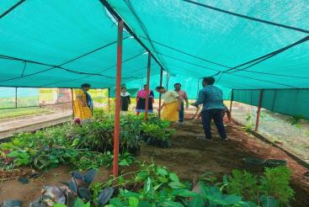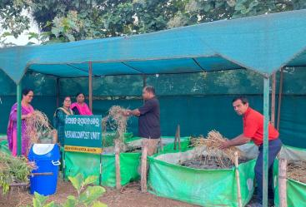  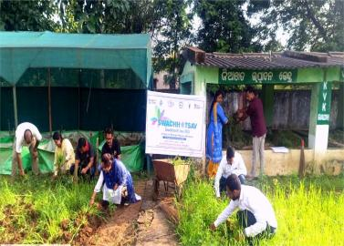
8 | 24.09.2025 | TouristSpots, Religious & SpiritualPlaces  Coordination with government departments,tourism bodies,and educational institutions for comprehensive participationin cleanliness drivesat high-footfalllocations. | 50 | Nil | 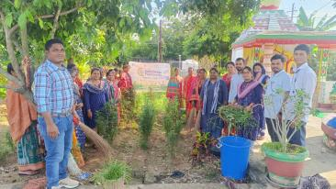  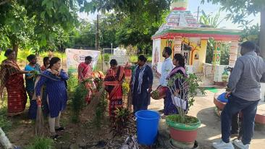
9 | 25.09.2025 | Ek Din, Ek Ghanta, Ek Saath –NationwideShramdan  - OrganisationofsimultaneousnationwideShramdanon25thSeptember2025,encouraging citizens to contribute one hour of voluntary Swachhata service.  - Mobilisationofparticipantsatlakhsofsitesacrossthecountry,followingthetraditionof previous years when crores of people voluntarily joined the cleanliness drive.  - Call to action for citizen participation,fostering community involvement and collective responsibility for thenation’s cleanliness.  - Facilitationofengagementbypoliticalleadershipandlocalauthoritiestoensuremaximum reach and impact. | 80 | Nil | 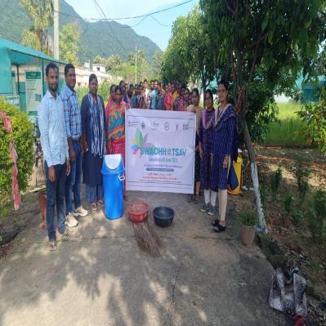  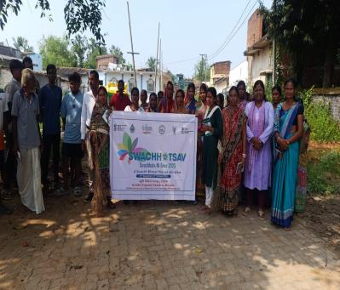
10 | 26.09.2025 | BestInnovationunderSwachhBharatMission(SBM) –Cultural Fests; Recognitionofthemostuniqueandinspiringinitiativesundertakenbylocalbodiesto integrate citizens with Swachhata, local art, music & culture. | Nil | Nil | Nil
11 | 27.09.2025 | WastetoArtInitiatives  - Creative initiatives at sanitation parks and selfie points in villages to transform waste into art and promote community pride.  - Display of decorative murals to enhance waste management facilities and encourage active community engagement. | 15 | Nil | 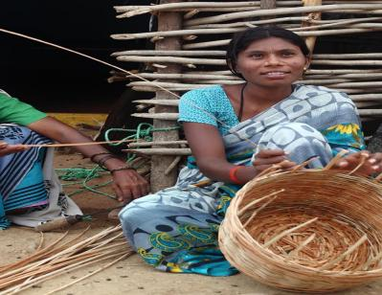
12 | 28.09.2025 | FacilitationofaccesstocomprehensivehealthservicesforSafaiMitras,sanitationworkers,andtheir dependents,includingenrolmentingovernmentschemessuchasAyushmanBharat,PM-JAY,Mission Indradhanush, and other relevant state-level programs to ensure better health and well-being. | Nil | Nil | Nil
13 | 29.09.2025 | - ProvisionofPPEkitsandprotectivegear to safeguardsanitationworkersfromoccupational hazards.  - Organisationofspecialdrives,  including walkathons and cycle rallies,to raise awareness about sanitation, hygiene, and safety practices among workers and the community. | Nil | Nil | Nil
14 | 30.09.2025 | SocialWelfareLinkagesandRegistrationofSanitationWork  Facilitationofregistrationandlinkageofsanitationworkersandtheirfamilieswithvarious social welfare schemes to ensure comprehensive benefits.  Keyschemestobecoveredinclude,butarenotlimitedto:  - Housing:PradhanMantriAwasYojana(PMAY)  - Sanitation/Toilet Facilities: Atal Mission for Rejuvenation & Urban Transformation (AMRUT), Jal Jeevan Mission (JJM), and relevant state schemes  - Electricity:PMSahajBijliHarGharYojana (Saubhagya)  - CookingFuel(LPG):PMUjjwalaYojana  - HealthServices&Insurance:AyushmanBharat,PMJanArogyaYojana(PM-JAY), ImmunisationunderMissionIndradhanush  - CreditAccess&FinancialInclusion:SwachhataUdyamiYojana(SUY),bankfinancing linkages  - Banking&SocialSecurity:PMJanDhanYojana,OneNationOneRationCard, MGNREGA Job Card, Pension Schemes, Aadhaar registration, as required. | 60 | Nil | 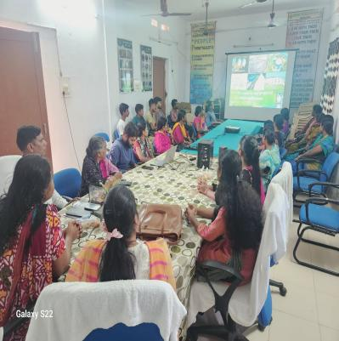  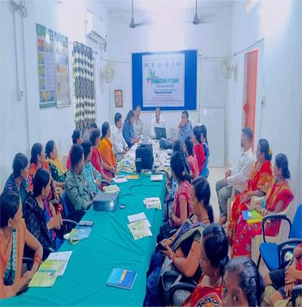
15 | 01.10.2025 | ReligiousLeaderEngagementandMedia Outreach  - Involvementofreligiousleadersincleanlinessdrivesatreligiousplacestopromote community participation in Swachhata initiatives.  - OrganisationofpressconferencestohighlighttheactivitiesofSwachhtaHiSewa,engaging all stakeholders including farmers, VIPs, media representatives, and electronic media. | Nil | Nil | Nil
16 | 02.10.2025 | SwachhBharatDiwasCelebrations  As part of the annua lSwachh Bharat Diwas celebrations, simultaneous events are proposed on2ndOctober 2025 across villages and cities.  - PrabhatPheris–Early morning cleanliness marches to promote community participation.  - Recognition of Safai Mitras for their contributions to sanitationandhygiene.  - Awards forcompetitions andpujacommodities, highlighting bestpractices and community engagement.  - Highlighting,showcasing,andcelebratingtransformationofCleanlinessTargetUnits (CTUs/).  - Felicitationoflocalsanitationworkersandcitizeninfluencerstoacknowledgetheir contribution to the mission.  - CelebratingachievementsofSHS2025–SwachhFoodStreetsInitiative,SBMCulturalFests, etc.  - Recognitionofbest-performingvolunteersandpartnersforSHS2025 initiatives.  - On-groundShramdaanandploggingdrivesbycitizens,politicalleadership,SBMAmbassadors, youth groups, NGOs, CSOs, partner organizations, and influencers.  - Swachhata Sabha at villages –Conduct special Gram Sabhas where villages may be declared.  ODFPlus/ ODFPlusModel.  - Dedicated segments for SafaiMitras and their families to perform or display skills in local music, dance, or art, providing a platform to share their talents and contributions.  - Feature stories from SafaiMitrasabout their experiences and the importance of their work, throughinterviews,livestorytelling,ordramatizedperformancesattheSwachhBharatCultural Fest.  - Waste to Wealth workshops to train SafaiMitras on creating products from upcycled materials, promoting the principles of Reduce, Reuse, Recycle. | 105 | Nil | 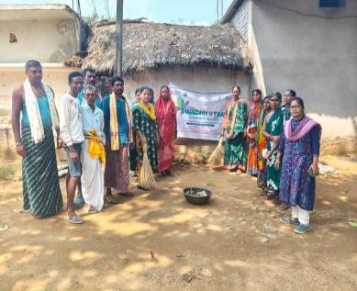  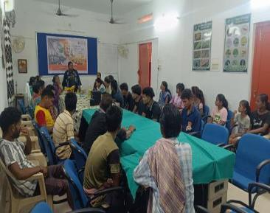  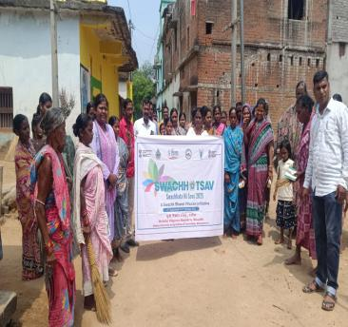  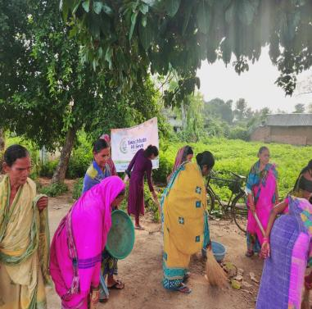
 |  | Total | 603 | Nil

Sd/-
Sr.Scientist & Head
KVK, Boudh

