LIVE STREAMING OF THE LAUNCHING EVENT FOR THE PM DHAN-DHAANYA KRISHI YOJANA (PMDDKY) AND NATIONAL PULSES MISSION
Organized by: Krishi Vigyan Kendra (KVK), Boudh
Date: 11.10.2025
Time:10.00 AM Onwards
Venue: NHRDF Conference Hall
Mode: Live streaming of the National Launch from New Delhi

Krishi Vigyan Kendra (KVK), Boudh, successfully organized a live streaming of Launching event for farmers and stakeholders to witness the national launch of the Prime Minister Dhan-Dhaanya Krishi Yojana (PMDDKY) and the National Pulses Mission at NHRDF Conference hall, Paljhar, Boudh.The program, attended by a total 184 nos. Of farmers, farm women,Rural Youth, SHG members, FPO members, NGO members participated in the program making it a significant step towards enhancing agricultural productivity and farmer welfare in Boudh district and as a part of the convergence efforts and to support rabi season preparedness and 10 nos. Of agricultural officials aimed to disseminate crucial information about these landmark agricultural initiatives. The event facilitated a direct connection between local farmers and the national leadership, reinforcing the Government's commitment to strengthening the agricultural sector and promoting self-reliance in pulses.
Event Objectives:
- To facilitate live streaming of the national-level launching event of the PMDDKY and National Pulses Mission for the benefit of farmers and other stakeholders.
- To sensitize farmers about the objectives and benefits of PMDDKY and the National Mission on Pulses.
- To disseminate the key messages of Hon’ble Union Minister for Agriculture & Farmers Welfare among local farming communities and encourage the adoption of modern agricultural techniques and sustainable farming practices promoted under the new initiatives.
- To provide a platform for interaction between KVK scientists and farmers, addressing their queries related to the schemes.

Event Details:
The event began with a welcome address by Sj. Tapan Kumar Das, KVK Head, who briefed the audience on the importance of the new schemes and highlighted how these initiatives would benefit farmers in the district. The main highlight was the live telecast of the national launching event. The participants viewed the addresses by the Prime Minister and other senior officials, who detailed the components of PMDDKY and the National Pulses Mission. The KVK, Boudh ensured a stable and clear broadcast for all attendees.

FPO-Level Participation
In addition to the KVK-level event, one Farmer Producer Organization (FPO) associated with KVK, Boudh Nilakantheswar FPO also organized a village-level live streaming and awareness programme on the launching of PM-Dakshyata (PMDDKY) and National Mission on Pulses. The event was conducted under the technical guidance and supervision of KVK scientists. Around 35 farmers and FPO members participated at the village venue, where the live telecast was followed by an interactive discussion on opportunities available under the new initiatives, including pulse seed production, and market linkage support. The programme successfully extended the outreach of the national launch to the grass-root farmer groups, reinforcing the collaborative approach between KVK and FPOs for technology transfer, capacity building, and inclusive agricultural development.
Key points from the national address:
  - PMDDKY: Focus on enhancing productivity, sustainable practices, and improving agricultural infrastructure like storage facilities.
  - National Pulses Mission: Aimed at achieving self-sufficiency in pulse production through a multi-year strategy involving research, market linkages, and assured procurement.
Interactive Session
Following the live telecast, KVK scientists conducted an interactive session. Using local examples, they explained how the schemes would be implemented in the district. They addressed farmers' questions regarding eligibility criteria, application procedures, and specific benefits.
Distribution of Information Materials about PMDDKY:To demonstrate support and encourage immediate action, the KVK distributed information brochures to the participating farmers. The programme has eneded with vote of thanks by Mrs. Sasmita Pal, Scientist(H.Sc).
Promotion & Outreach
- The event was promoted through social media, Twitter, local radio, and WhatsApp groups to maximize reach.
Outcomes, Impact and Feedback
Enhanced Awareness: The live streaming effectively raised awareness among local farmers about the new government programs. Strengthened the link between KVK and farmers for future interventions. Created a motivation among farmers to adopt improved pulse technologies and skill-based enterprises.Established a knowledge-sharing environment encouraging community participation in pulse development programmes.
Feedback from Participants: Farmers appreciated the opportunity to witness the national-level event live and expressed enthusiasm to avail pulse cultivation benefits. Participants requested for follow-up training and demonstrations on improved pulse varieties and seed production techniques under KVK guidance. Several SHG members, NGO members and FPO members showed interest in pulse-based value addition and processing activities.
Report:
Name of the KVK & State | Name of the ATARI | Total Male | Total Female | Total nos. Of Farmers & Farm Women | Total Nos. of FPO Member | Total nos. of NGO members | Total nos. Of Official Person | Total nos. Of participants
KVK, Boudh, Odisha | ATARI, Kolkata, Zone V | 105 | 65 | 170 | 10 | 04 | 10 | 194

Photographs:
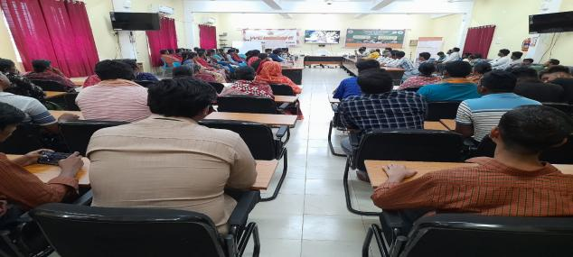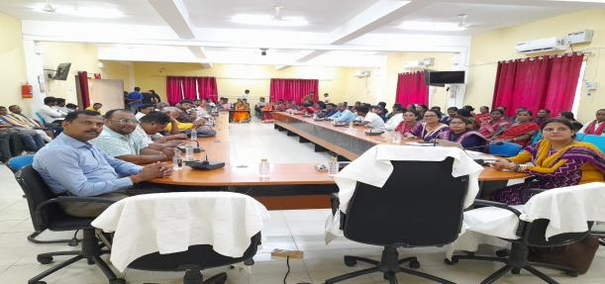
Participants attending live streaming
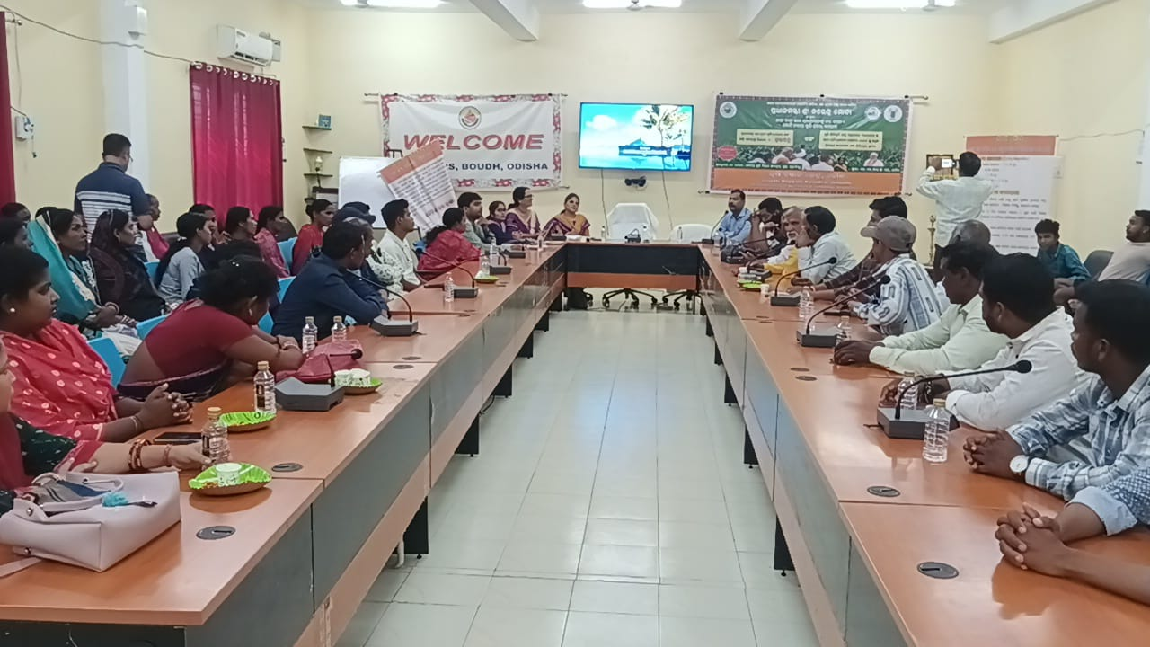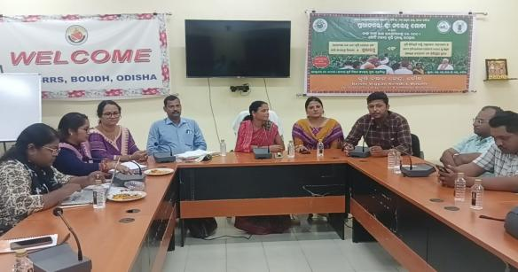
Feedback sharing by the NGO members
KVK Head addressing the gathering

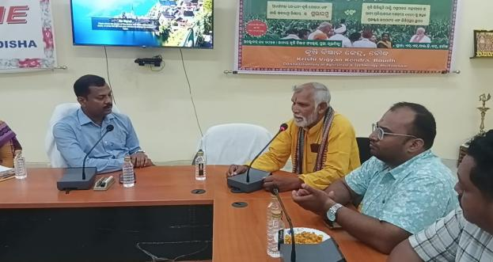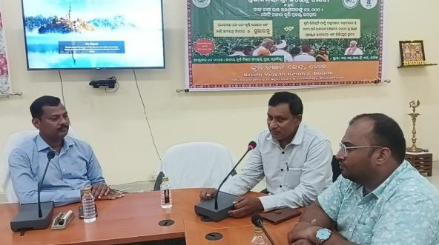
Interaction with farmers, FPO members in post-event

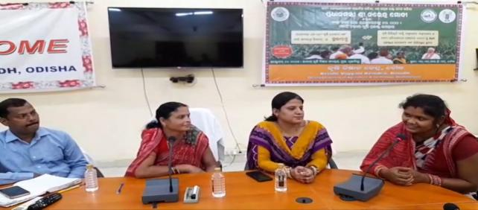
Prog. Eneded with Vote of thanks.
Interaction with SHG members

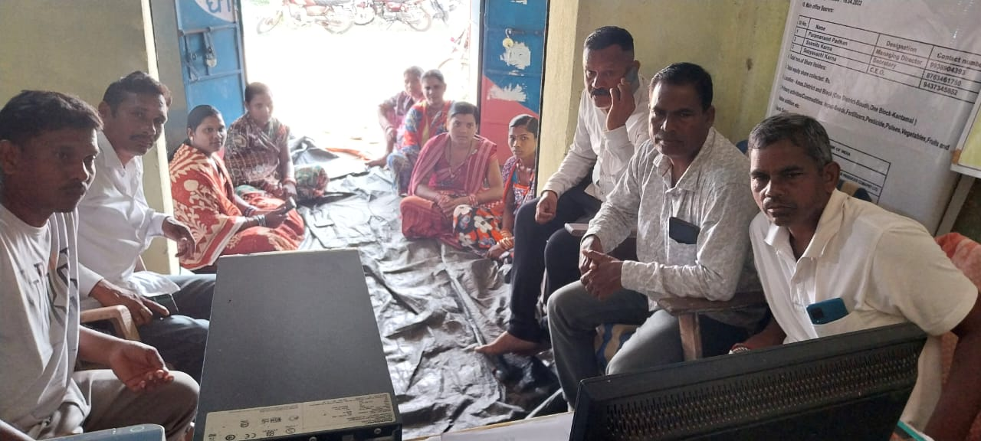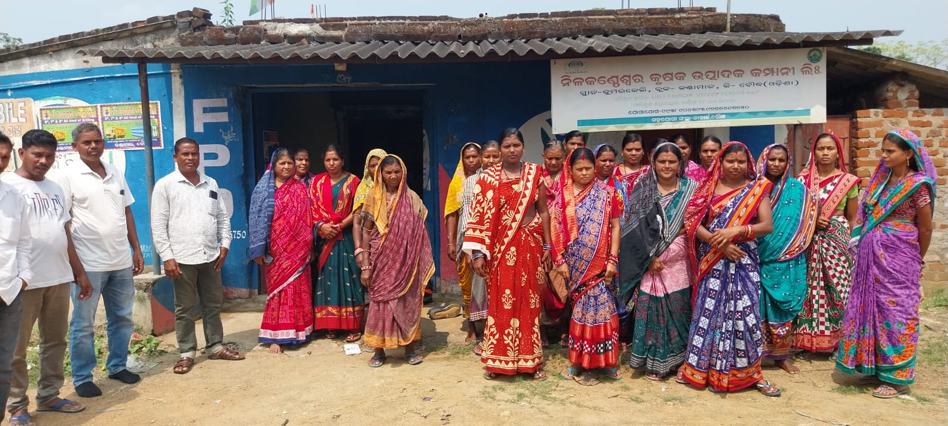
Village level participation by Nilakantheswar FPO, at Kumarkeli village, Kantamal, Boudh

Media Outreach:
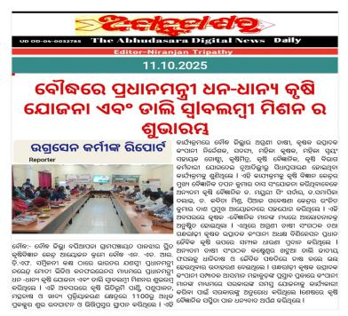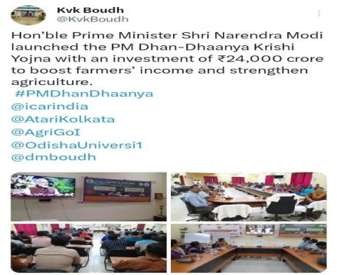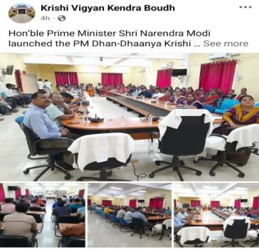
Conclusion
The live streaming of the PMDDKY and National Pulses Mission launch proved to be a highly successful and impactful event for KVK, Boudh. By leveraging technology, the KVK strengthened the connection between national policy initiatives and the local farming community. The program not only disseminated vital information but also motivated farmers to actively participate in the government's vision for a self-reliant and prosperous agricultural sector.

Sd/-
Sr. Scientist & Head
KVK, Boudh

