
Report on Vigilance Awareness Week 2025
Name of the KVK: Krishi Vigyan kendra, Boudh
A. INTEGRITY PLEDGE

Table- 1: Integrity Pledge

Total no. of employees who have undertaken pledge | Total no. of farmers who have undertaken pledge | Total no. of citizen other than farmers who have undertaken pledge
15 | Farmers:50  Rural Youth: 50  Farm women:30 | 70

B. ACTIVITIES/ EVENTS ORGANISED WITHIN THE KVK

Table- 2: Conduct of Competitions

Name of city/ place | Specific program (Debate/ panel discussion etc) | Name of first two winners | No. of participants | Whether copy of award winning activities attached
- | - | - | - | -

Table- 3: Other Activities

Sl. No. | Activities | Details
1 | Distribute Pamphlets/ Display of Banners | During the programme, pamphlets on hygienic utilization of crop residue, vermicompost preparation were distributed among the farmers, farm women, and rural youth. Informative banners highlighting key messages on “Swachhata Hi Seva,” “Clean Farm–Green Farm,” and “Waste to Wealth” were displayed at the KVK campus to create mass awareness.
2 | Conduct of Workshop/ Sensitization Programs | As part of the observance, a Workshop and Sensitization Programme was organized at the KVK campus to create awareness among staff,students of agro polytechnic centre, Boudh, farmers, farm women, and ASHA workers about the importance of transparency, integrity, and accountability in public life.
3 | Issue of Newsletter | KVK, Boudh will be released in this month a special issue in Newsletter highlighting activities related to transparency, integrity, and accountability in public service.
4 | Any other activities | -

C. ACTIVITIES/ EVENTS ORGANIZED OUTSIDE THE KVK

Table- 4: Involving Students in Schools

Name of city/ town/ place | Name of school | Details of activities conducted including mentioning date of activities conducted | No. of students involved | Whether copy of award winning activities attached
Baghiapada | Mendhimal Govt. High School. | Spread awareness about the importance of vigilance, the values of honesty and vigilance among students at Baghiapada involving 30 nos. of students from Mendhimal Govt. High School, Kanakpur Upper Primary School on dt. 02.11.2025. | 30 nos.

Table- 5: Involving Students in Colleges

Name of city/ town/ place | Name of college | Details of activities conducted including mentioning date of activities conducted | No. of students involved | Whether copy of award winning activities attached
Paljhar, Boudh | Agro polytechnic Collage, Boudh | Sensitize students on the theme “Say No to Corruption; Commit to the Nation.” Activities such as integrity pledge, debates & awareness programme were conducted. Students participated enthusiastically, promoting values of honesty,transparency and ethical conduct among the younger generation on dt 27.10.2025. | 19 | -

Table- 6: Awareness Gram Sabhas

Name of city/ town/ village | Name of Gram Panchayat where ‘Awareness Gram Sabha’ was held | Details of activities conducted including mentioning date of activities conducted | No. of public/ farmers/ citizens participated
Boudh | - GP: Baghiapada  (village: Kanakpur)  - GP: Baghiapada  (village: Mendhimal)  - GP: Khatkhatia  (Village: Kumarkeli) | Organize Gram Sabhas at Kanakpur, Mendhimal and Kumarkeli village to sensitize rural communities about the importance of integrity and transparency in public services involving 100 nos. Of farmers , farm women and other citizens. | 100 nos.

Table- 7: Seminars/ Workshops

Name of city/ town/ village | No. of seminars/ workshops organised | Details of activities conducted including mentioning date of activities conducted | No. of public/ citizens participated
Boudh | 01 | Local rural youths attended the seminar on vigilance awareness and its importance, vigilance awareness sensitising programme was organised at KVK Campus and Group discussion on Corruption free India, on dt 29.10.2025. | 25

Table- 8: Other Activities

Sl. No. | Activities | Details
1 | Display of Banners/ Posters etc | Display of banner at KVK premises and adopted villages to increase the awareness and max. Reach out to the people.
2 | No. of grievance redressal camps held | -
3 | Use of Social Media | Public outreach program via social media (Twitter & Facebook) and Print Media.

D. DETAILS OF PHOTOS ENCLOSD
(Photos may kindly be sent along with captions and also place and date of event)

Name of the activities held | Photo attached
All employees of KVK Boudh gathered to take the integrity pledge, emphasizing their commitment to honesty and fairness in their personal and professional lives on dt. 27.10.2025 involving 10 nos. of staffs and Official staffs and students of APC, Boudh. | 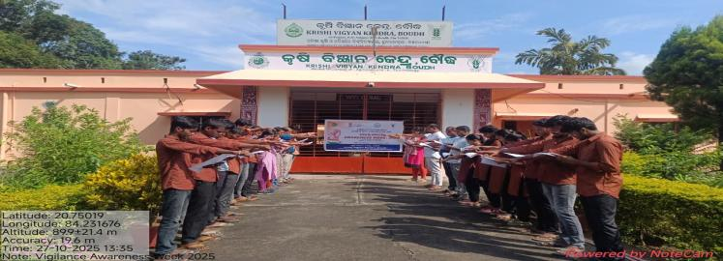
Spread awareness about the importance of vigilance, the values of honesty and vigilance among students at Baghiapada with the students of Mendhimal Govt. High school on 2nd November, 2025. | 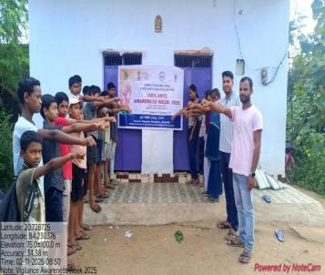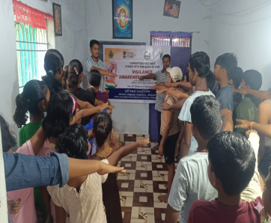
Organized gramsabhas at Kanakpur village to sensitize rural women about the importance of integrity and transparency in public services involving 35 nos. of Farmer, farm women and other citizens. | 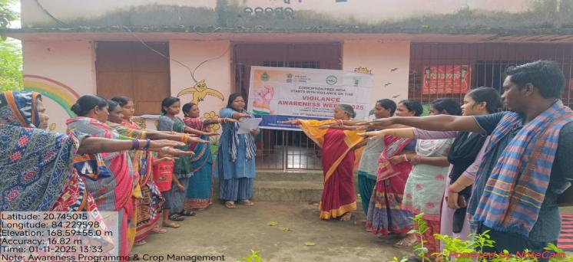
Taking Integrity pledge with the villagers of Kumarkeli , GP: Khatkhatia, Kantamal block, Boudh on dt 31.10.2025. | 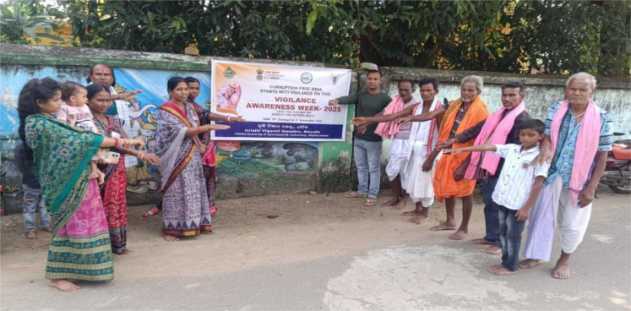
Organized sessions starting with taking integrity pledge involving 19 nos. Of Agri Polytechnic Collage students of APC, Boudh that focus on the importance of vigilance, ethical governance, and anti-corruption measures within the agricultural sector at APC, Boudh on dt. 27.10.2025. | 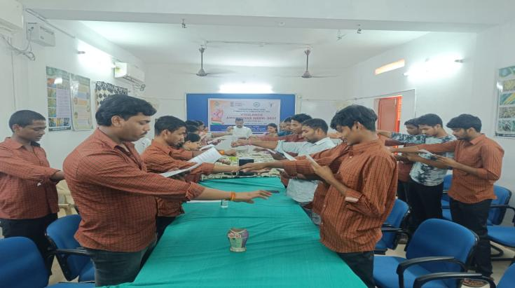
Organized awareness session with collaboration of CHO about the feedback from the 15 nos. Of health worker(ASHA) and motivate to other village women for maximum public awareness within the women. | 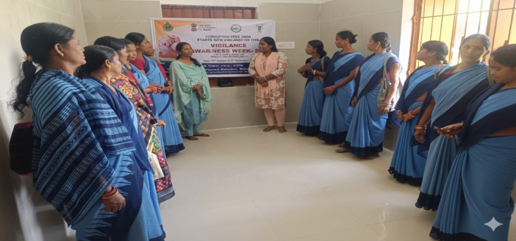
Program via social media ( Facebook and Twitter) and print media by KVK, Boudh for maximum Public outreach. | 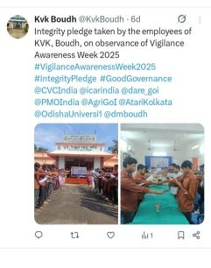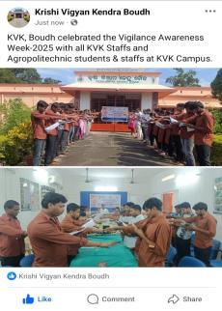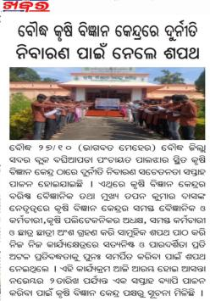

Sd/-
Sr. Scientist & Head
KVK, Boudh

